Supporting Information

Silica-Supported Magnetic Nanoparticles Functionalized with Phosphorus Species (Fe₃O₄@SiO₂–O–PCl₂): An Efficient and Recyclable Catalyst for the One-Pot Synthesis of Isatin-Based Imidazoles under Mild and Green Conditions
Somayeh Zare, Arezu Jamalian*, Masoomeh Emadi

Department of Chemistry, Marv.C., Islamic Azad University, Marvdasht, Iran
*Corresponding author: jamalian@iau.ac.ir (A. Jamalian)

Table of Contents
Section | Page
1. Spectroscopic Data of All Compounds | S2–S3
2. ¹H and ¹³C NMR Spectra of Representative Products | S4–S8
3. EDX Analysis of Recovered Catalyst After Five Runs | S9
4. References | S10

- Spectroscopic data of the Compounds

2-(p-Tolyl)-3,4-dihydroimidazo[4,5-b]indole (Scheme 2, 4a)

yellow solid, mp 310-312 ˚C (Lit.[1] > 300 °C); IR (KBr) cm⁻¹: 3390 (N-H, str), 3067 (C-H, aromatic, str.), 2943 (C-H, str.), 1595 (C=N, str.), 1507, 1430 (Ar C=C, aromatic, str.), 1247 (-CH_{3,} str), 1202 (C-N, str.); ¹HNMR (DMSO-d₆): δ 9.16 [s, 1H, N-H], 8.24 [m, 1H, N-H], 8.04-8.00 [m, 4H, Ar-H], 7.53-7.51 [m, 2H, Ar-H], 7.45-7.41 [m, 2H, Ar-H], 2.42 [s, 3H, -CH₃]; ¹³CNMR (DMSO-d₆): δ 167.95, 150.18, 135.14, 131.79, 130.34, 129.85, 129.04, 126.56, 123.62, 120.40, 115.51, 21.41. Anal. Calcd for C₁₆H₁₃N₃: C, 77.71; H, 5.30; N, 16.99. Found: C, 77.64; H, 5.32; N, 16.87.

2-phenyl-3,4-dihydroimidazo[4,5-b]indole (Scheme 2, 4b)

Yellow solid; Yield: 88%; M.p.: 310–312 °C (Lit. [1] >300 °C); IR (KBr, cm⁻¹): 3390 (NH), 3067 (Ar-H), 2943 (C-H), 1595 (C=N), 1507, 1430, 1247, 1202; ¹H NMR (400 MHz, DMSO-d₆): δ 9.16 (s, 1H, NH), 8.24 (s, 1H, NH), 8.04–8.00 (m, 4H, Ar-H), 7.53–7.51 (m, 2H, Ar-H), 7.45–7.41 (m, 2H, Ar-H); ¹³C NMR (100 MHz, DMSO-d₆): δ 167.95, 150.18, 135.14, 131.79, 130.34, 129.85, 129.04, 126.56, 123.62, 120.40, 115.51; Anal. Calcd for C₁₅H₁₁N₃: C, 77.24; H, 4.75; N, 18.01. Found: C, 77.19; H, 4.78; N, 17.93.

2-(2-Nitrophenyl)-3,4-dihydroimidazo[4,5-b]indole (Scheme 2, 4e)
Yellow solid, mp 170-171 ˚C (Lit.[1] 168-170 °C); IR (KBr) cm⁻¹: 3424 (N-H, str), 3073 (C-H, aromatic, str.), 2938 (C-H, str.), 1588 (C=N, str.), 1624, 1486 (Ar C=C, aromatic, str.), 1381 (NO₂, str.), 1270 (-CH_{3,} str), 1217 (C-N, str.); ¹HNMR (DMSO-d₆): δ 9.01 [s, 1H, N-H], 7.99-7.94 [m, 2H, Ar-H], 7.93 [s, 1H, N-H], 7.92-7.89 [m, 2H, Ar-H], 7.39-7.34 [m, 1H, Ar-H], 6.96-6.94 [m, 3H, Ar-H]; ¹³CNMR (DMSO-d₆): δ 166.56, 162.81, 160.52, 158.11, 148.13, 134.74, 132.75, 125.73, 123.47, 123.38, 116.10, 114.88, 114.64, 108.85, 108.58. Anal. Calcd for C₁₅H₁₀N₄O₂: C, 64.74; H, 3.62; N, 20.13; O, 11.50. Found: C, 64.69; H, 3.59; N, 20.05; O, 11.41.

2-(4-Chlorophenyl)-3,4-dihydroimidazo[4,5-b]indole (Scheme 2, 4f)

White solid, mp 219-220 ˚C (Lit.[1] 220 °C);IR (KBr) cm⁻¹: 3428 (N-H, str), 3063 (C-H, aromatic, str.), 2936 (C-H, str.), 1585(C=N, str.), 1626, 1484 (Ar C=C, aromatic, str.), 1267 (-CH_{3,} str), 1213 (C-N, str.), 1114 (C-Cl, str.); ¹HNMR (DMSO-d₆): δ 9.16 [s, 1H, N-H], 8.32 [s, 1H, N-H], 8.10-8.07 [m, 4H, Ar-H], 7.62-7.59 [m, 1H, Ar-H], 7.08-7.06 [m, 3H, Ar-H]; ¹³CNMR (DMSO-d₆): δ 167.12, 163.04, 150.30, 144.90, 134.90, 132.94, 125.64, 123.27, 120.24, 116.15, 115.41. Anal. Calcd for C₁₅H₁₀ClN₃: C, 67.30; H, 3.77; N, 15.70. Found: C, 67.37; H, 3.78; N, 15.61.

Compounds 4c, 4d, 4g, 4h, 4i, and 4j
The melting points, IR, ¹H NMR, and ¹³C NMR data for these compounds were found to be fully consistent with those previously reported in the literature [1]. No further characterization was required as these are known compounds.

- ¹H and ¹³C NMR spectra of the products

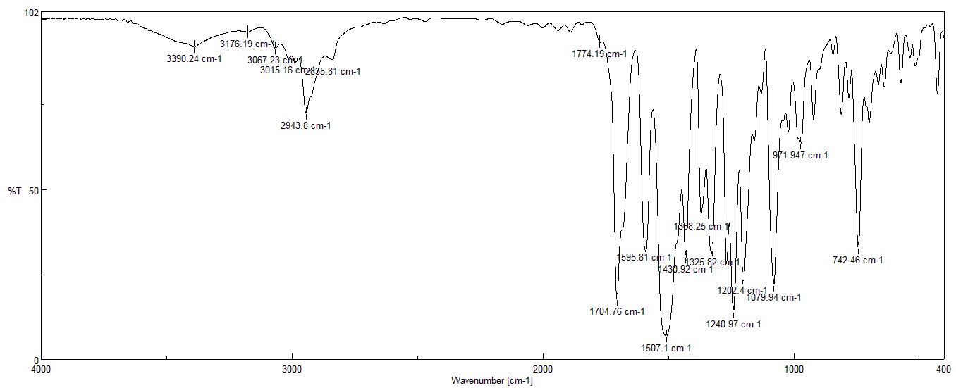
IR (KBr) cm⁻¹ (Scheme 2, 4b)

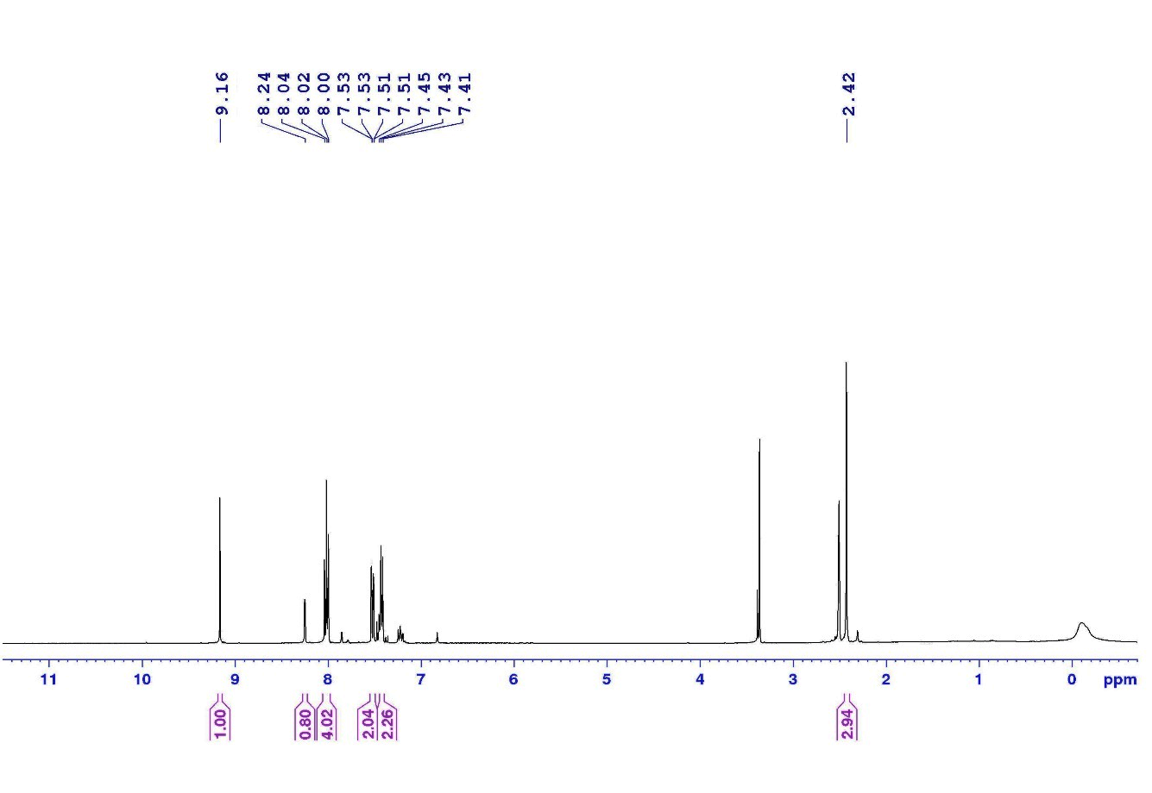
¹H NMR (100 MHz, DMSO-d₆); (Scheme 2, 4b)

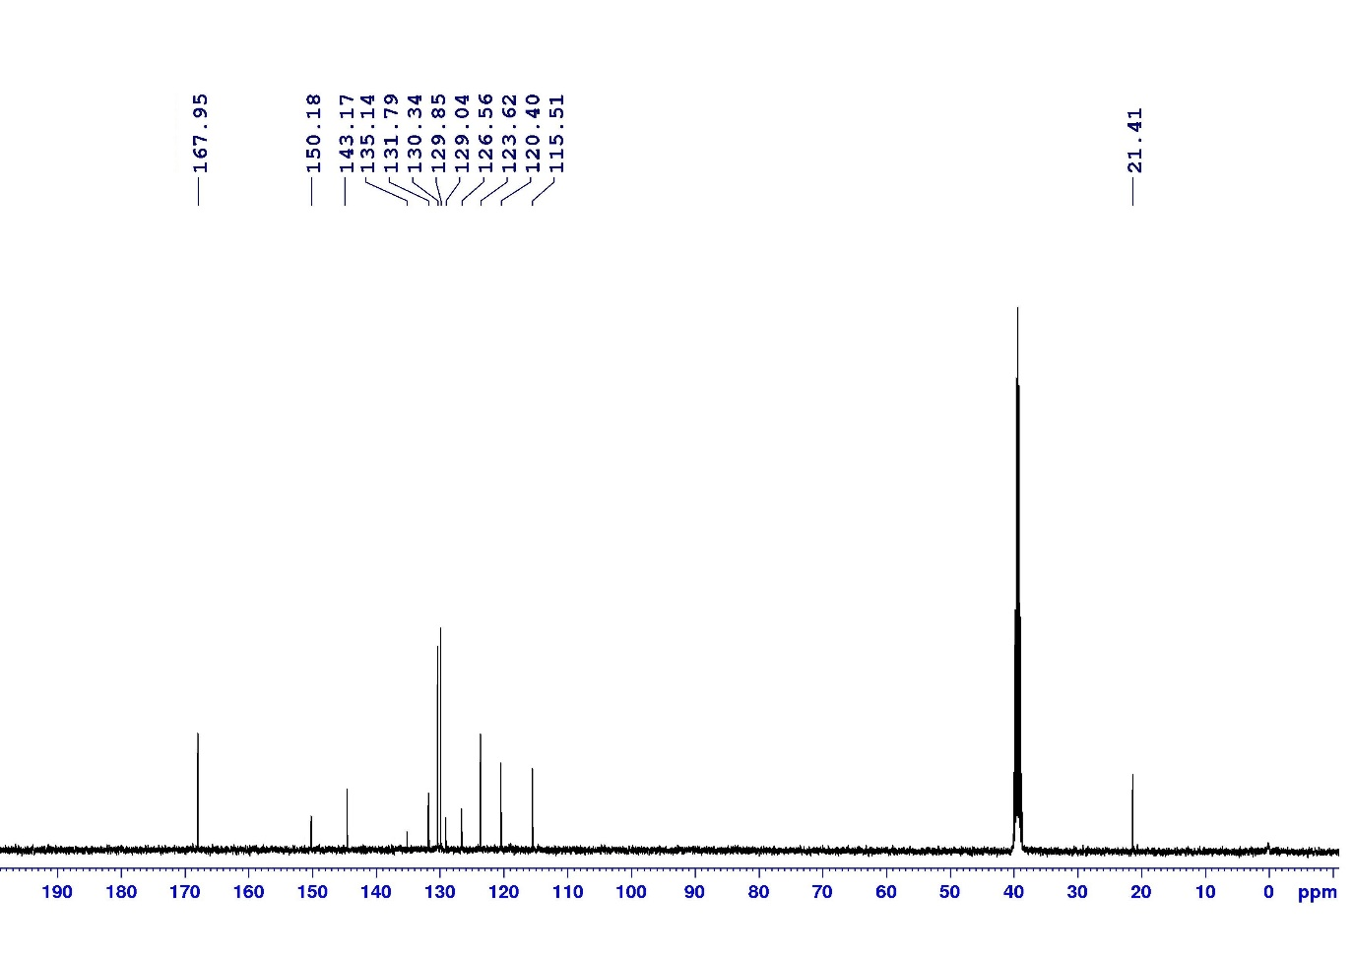
¹³C NMR (100 MHz, DMSO-d₆); (Scheme 2, 4b)

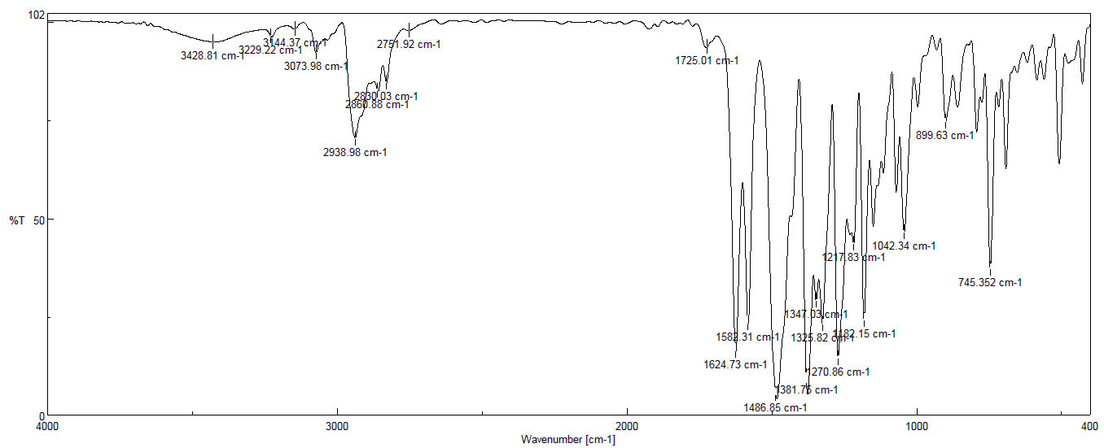
IR (KBr) cm⁻¹ (Scheme 2, 4e)

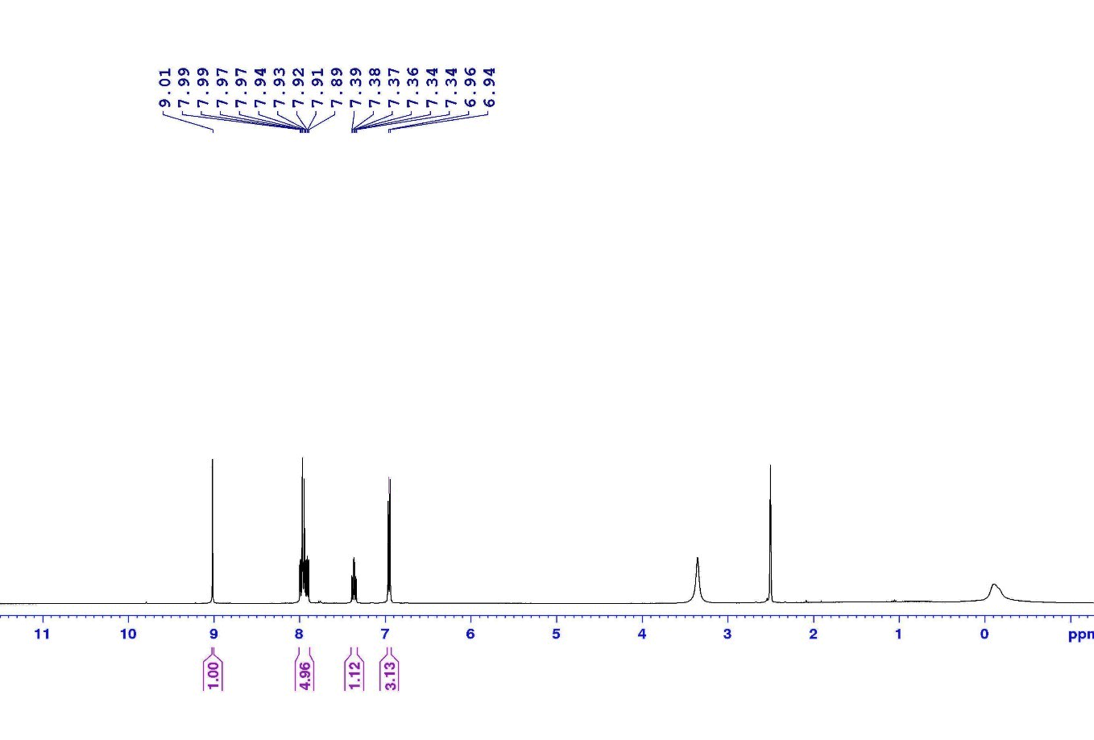
¹H NMR (100 MHz, DMSO-d₆); (Scheme 2, 4e)

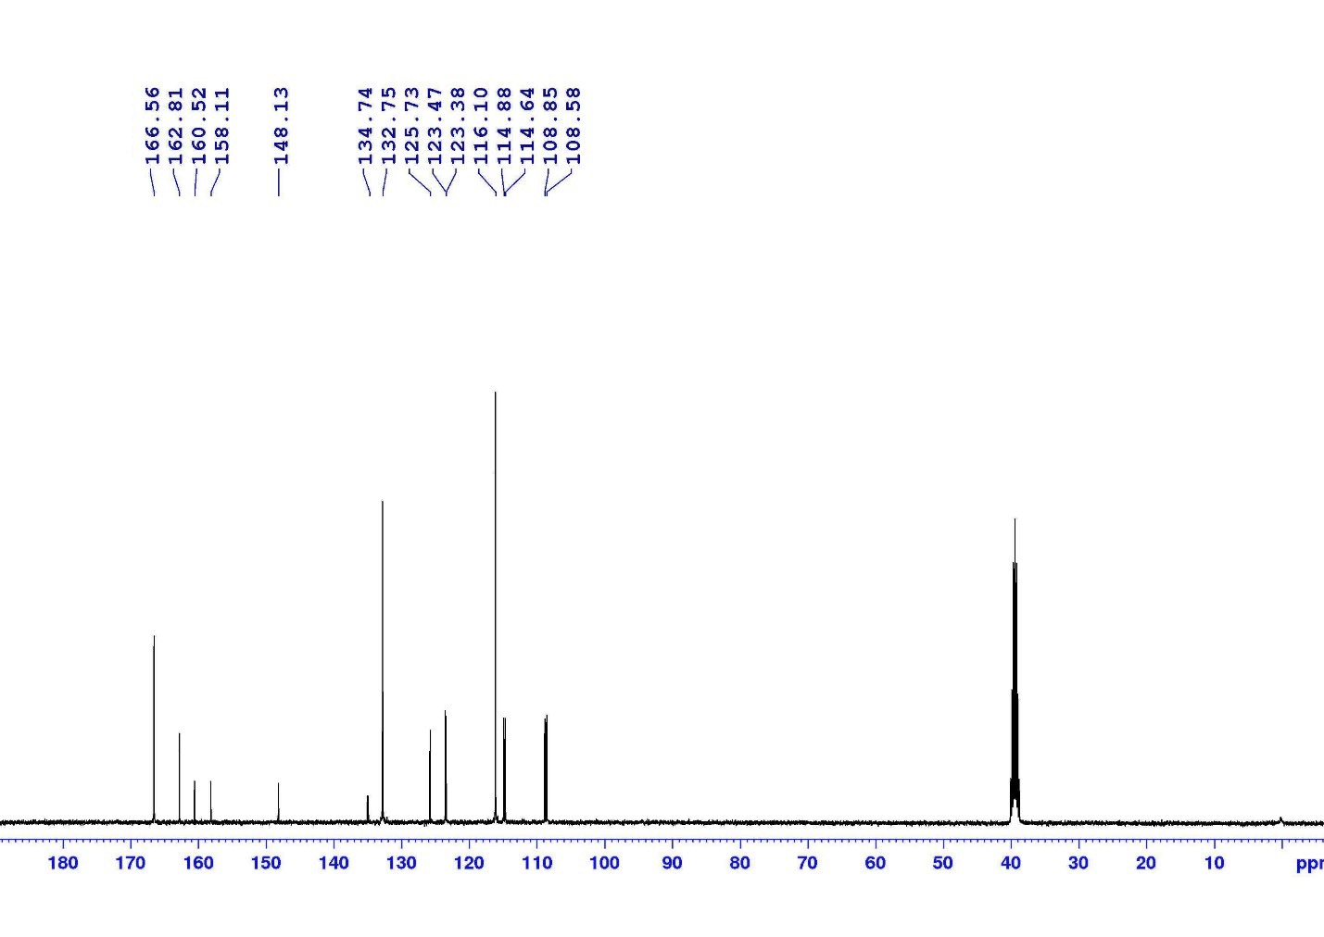
¹³C NMR (100 MHz, DMSO-d₆); (Scheme 2, 4e)

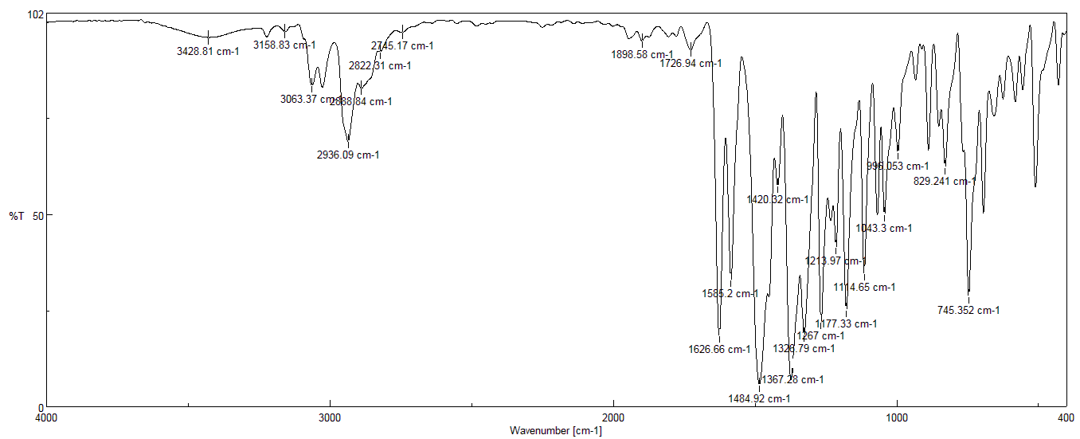
IR (KBr) cm⁻¹ (Scheme 2, 4f)

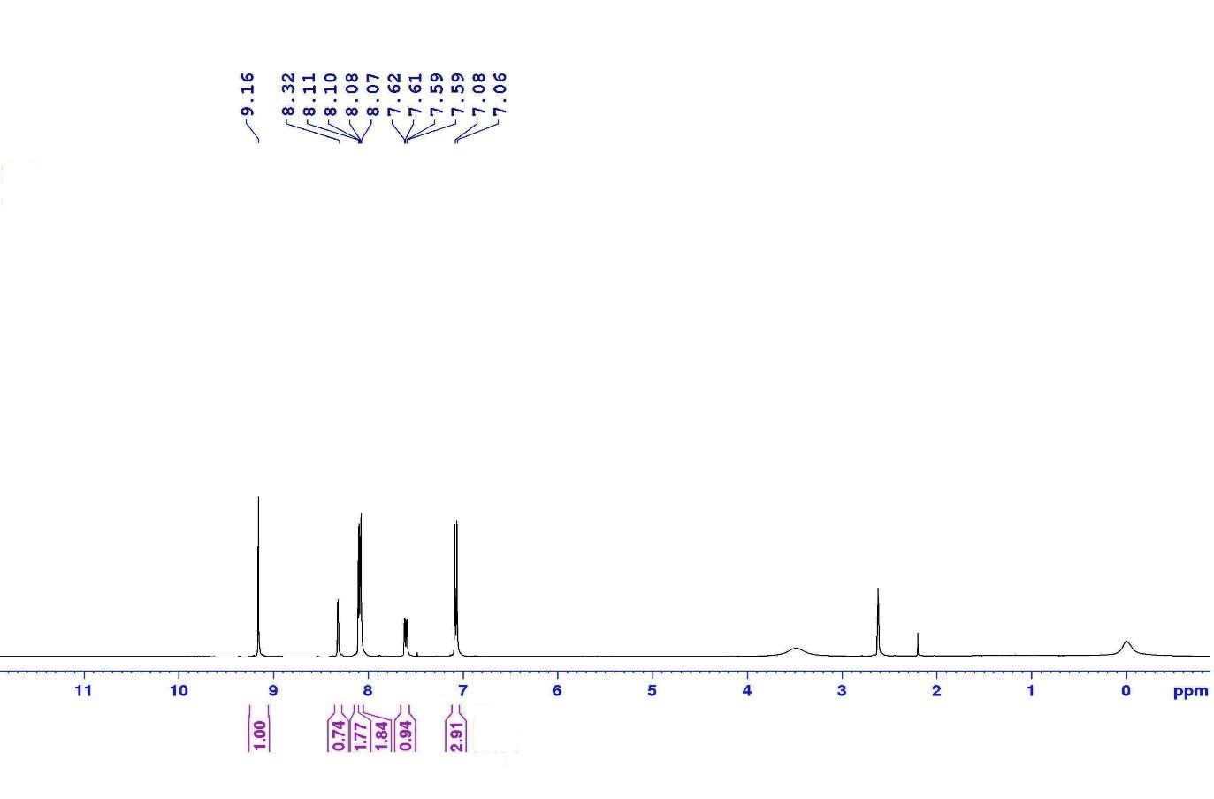¹H NMR (100 MHz, DMSO-d₆); (Scheme 2, 4f)

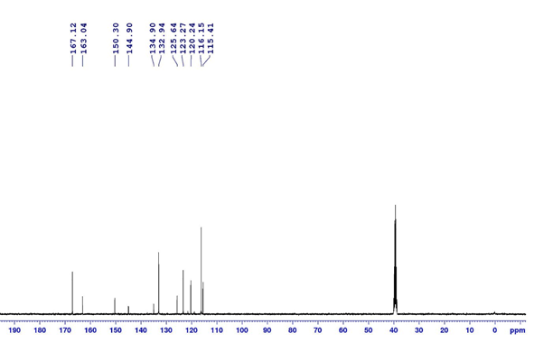
¹³C NMR (100 MHz, DMSO-d₆); (Scheme 2, 4f)

Table S1: Summary of Characterization Data for Compounds 4a–j
Comp. | R | Formula | M.p. (°C) (Found) | M.p. (°C) (Lit. [1]) | Yield (%) | Data Confirmation
4a | 4-CH₃ | C₁₆H₁₃N₃ | 275–277 | 275–277 | 90 | See detailed data below
4b | H | C₁₅H₁₁N₃ | 310–312 | >300 | 88 | See detailed data below
4c | 4-OCH₃ | C₁₆H₁₃N₃O | 268–270 | 268–270 [1] | 86 | Consistent with literature [1]
4d | 4-OH | C₁₅H₁₁N₃O | >300 | >300 [1] | 84 | Consistent with literature [1]
4e | 2-NO₂ | C₁₅H₁₀N₄O₂ | 170–171 | 168–170 | 83 | See detailed data below
4f | 4-Cl | C₁₅H₁₀ClN₃ | 219–220 | 220 | 87 | See detailed data below
4g | 4-Br | C₁₅H₁₀BrN₃ | 228–230 | 228–230 [1] | 85 | Consistent with literature [1]
4h | 4-CN | C₁₆H₁₀N₄ | 298–300 | 298–300 [1] | 82 | Consistent with literature [1]
4i | 3-NO₂ | C₁₅H₁₀N₄O₂ | 189–191 | 189–191 [1] | 80 | Consistent with literature [1]
4j | 4-N(CH₃)₂ | C₁₇H₁₆N₄ | 282–284 | 282–284 [1] | 84 | Consistent with literature [1]

3. EDX Analysis of Recovered Catalyst After Five Runs

Table S2: EDX elemental composition of the recovered Fe₃O₄@SiO₂–O–PCl₂ catalyst after five runs
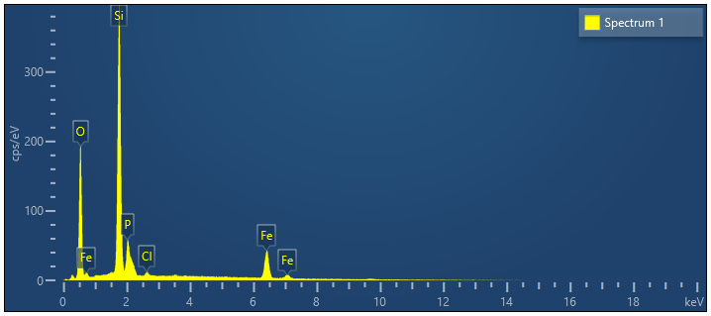
Spectrum 1
Element | Line Type | Weight % | Weight % Sigma | Atomic %
O | K series | 56.54 | 0.24 | 72.34
Si | K series | 28.56 | 0.18 | 20.82
P | K series | 4.28 | 0.12 | 2.83
Cl | K series | 0.54 | 0.05 | 0.31
Fe | K series | 10.07 | 0.14 | 3.69
Total |  | 100.00 |  | 100.00

4. References
[1] Nipate, A. S., Jadhav, C. K., Chate, A. V., Taur, K. S., & Gill, C. H. (2020). β‐Cyclodextrin catalyzed access to fused 1, 8‐dihydroimidazo [2, 3‐b] indoles via one‐pot multicomponent cascade in aqueous ethanol: Supramolecular approach toward sustainability. Journal of Heterocyclic Chemistry, 57(2), 820-829.

