Supporting Information

ZnFe₂O₄@Fe₃O₄ as a Heterogeneous Nanocatalyst in the Synthesis of the 1,8-Dioxooctahydroxanthene: Antioxidant and Antimicrobial Studies

Fatemeh Ghayem, Shefa Mirani Nezhad, Samanesadat Hosseini, Seied Ali Pourmousavi*

School of Chemistry, Damghan University, Damghan, 36716-45667

Corresponding author: pourmousavi@du.ac.ir (S.A. Pourmousavi)

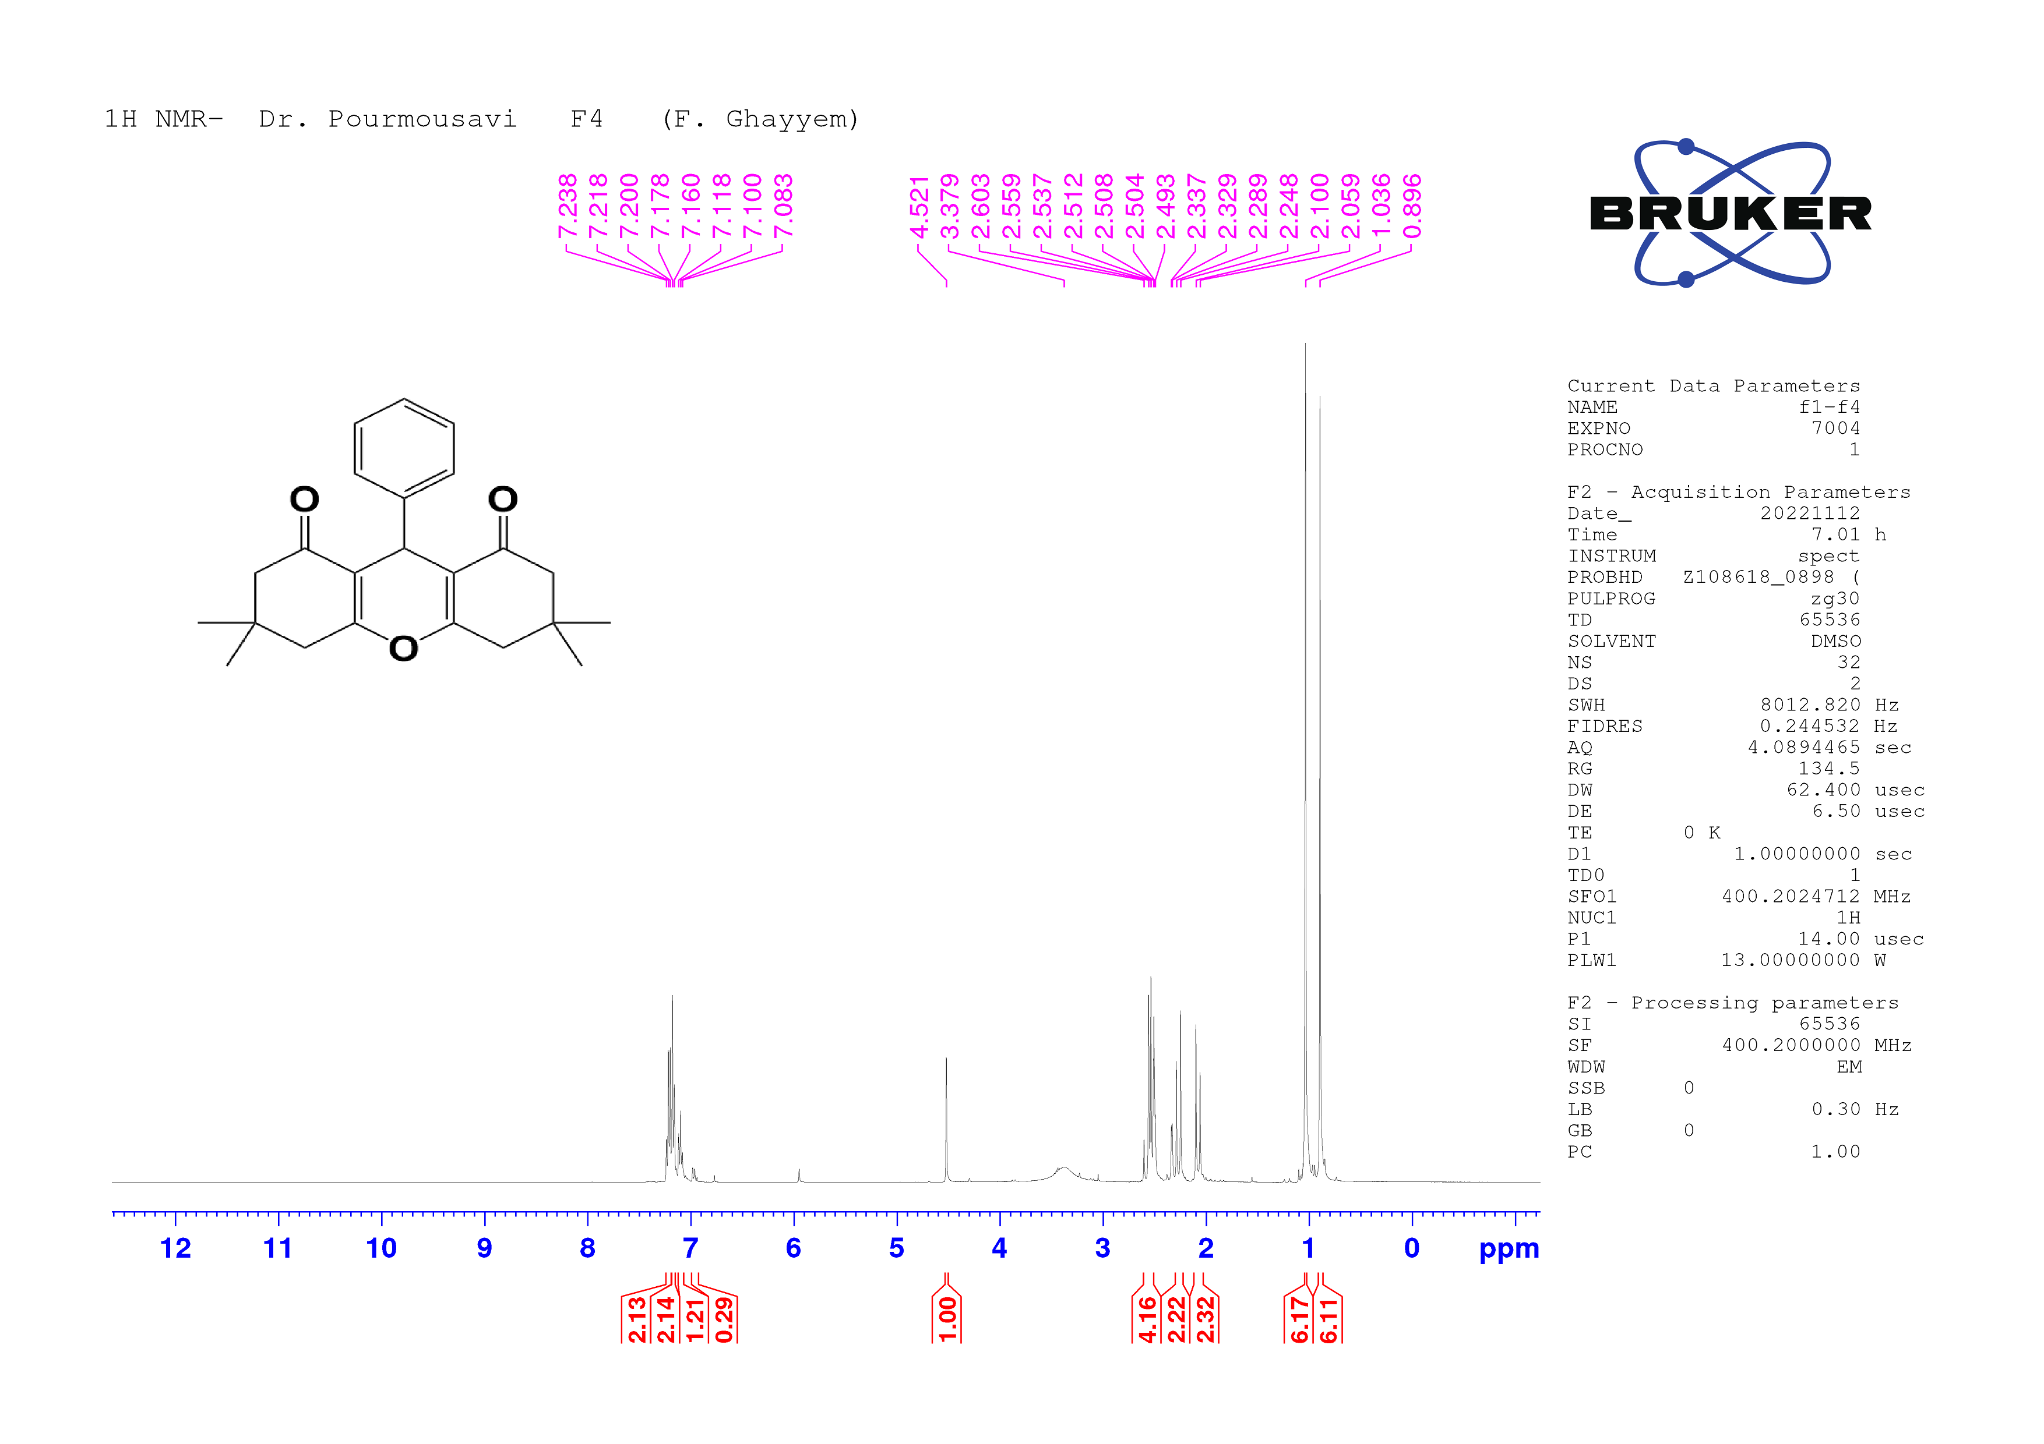

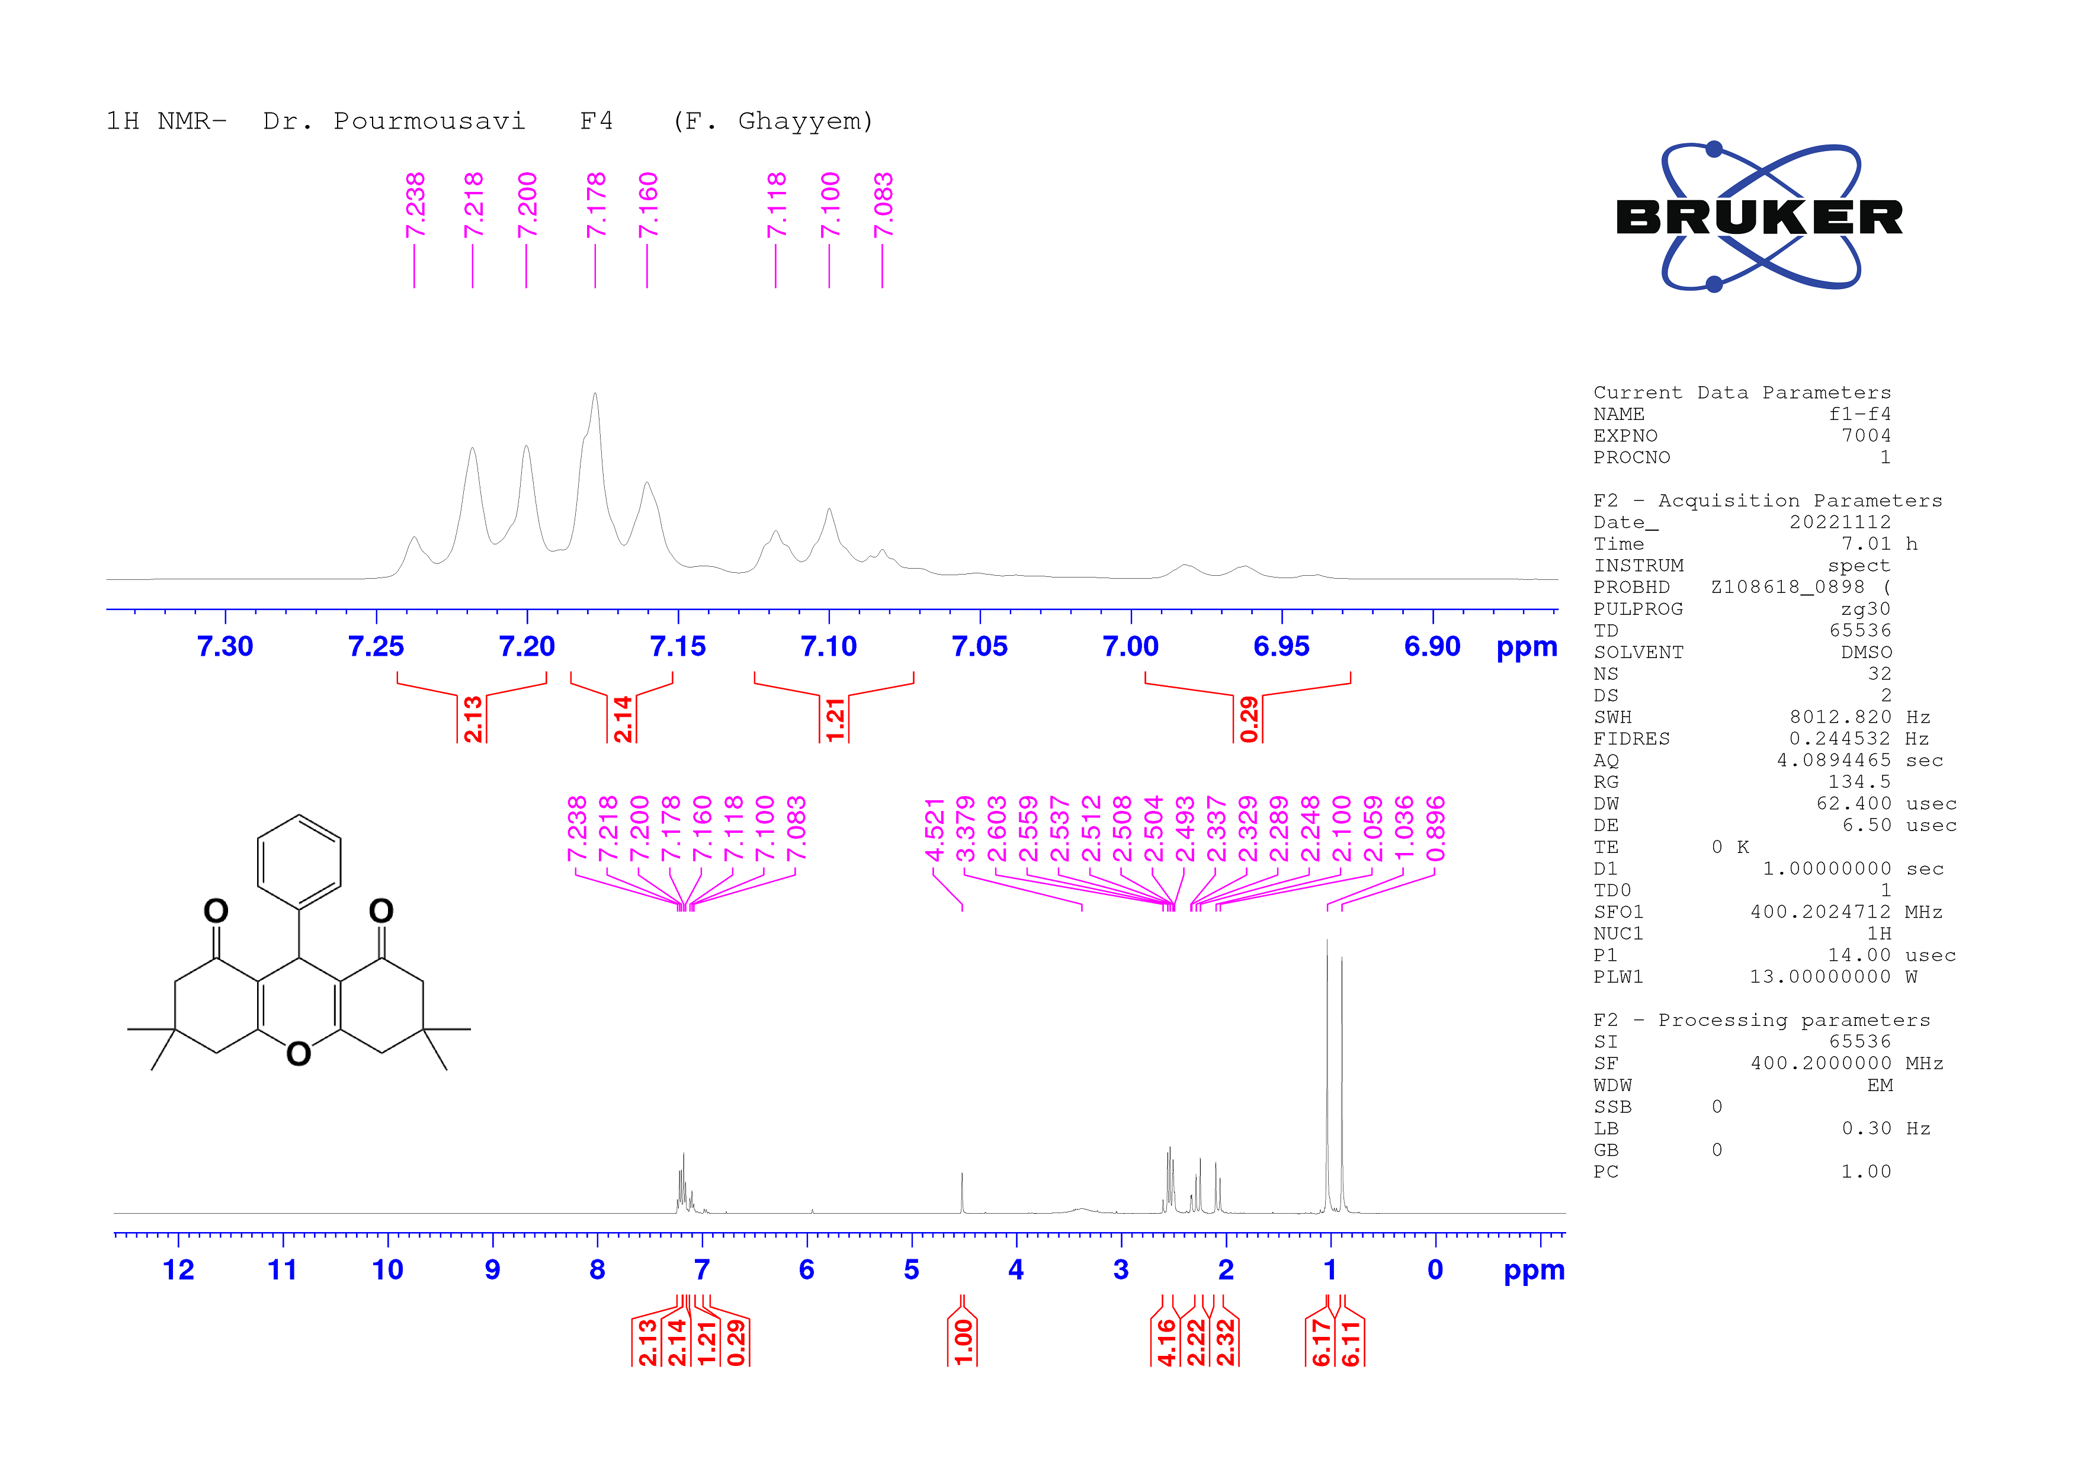

Figure S1: ¹H-NMR spectrum of 3,3,6,6-tetramethyl-9-phenyl-3,4,5,6,7,9-hexahydro-1H-xanthene-1,8(2H)-dione
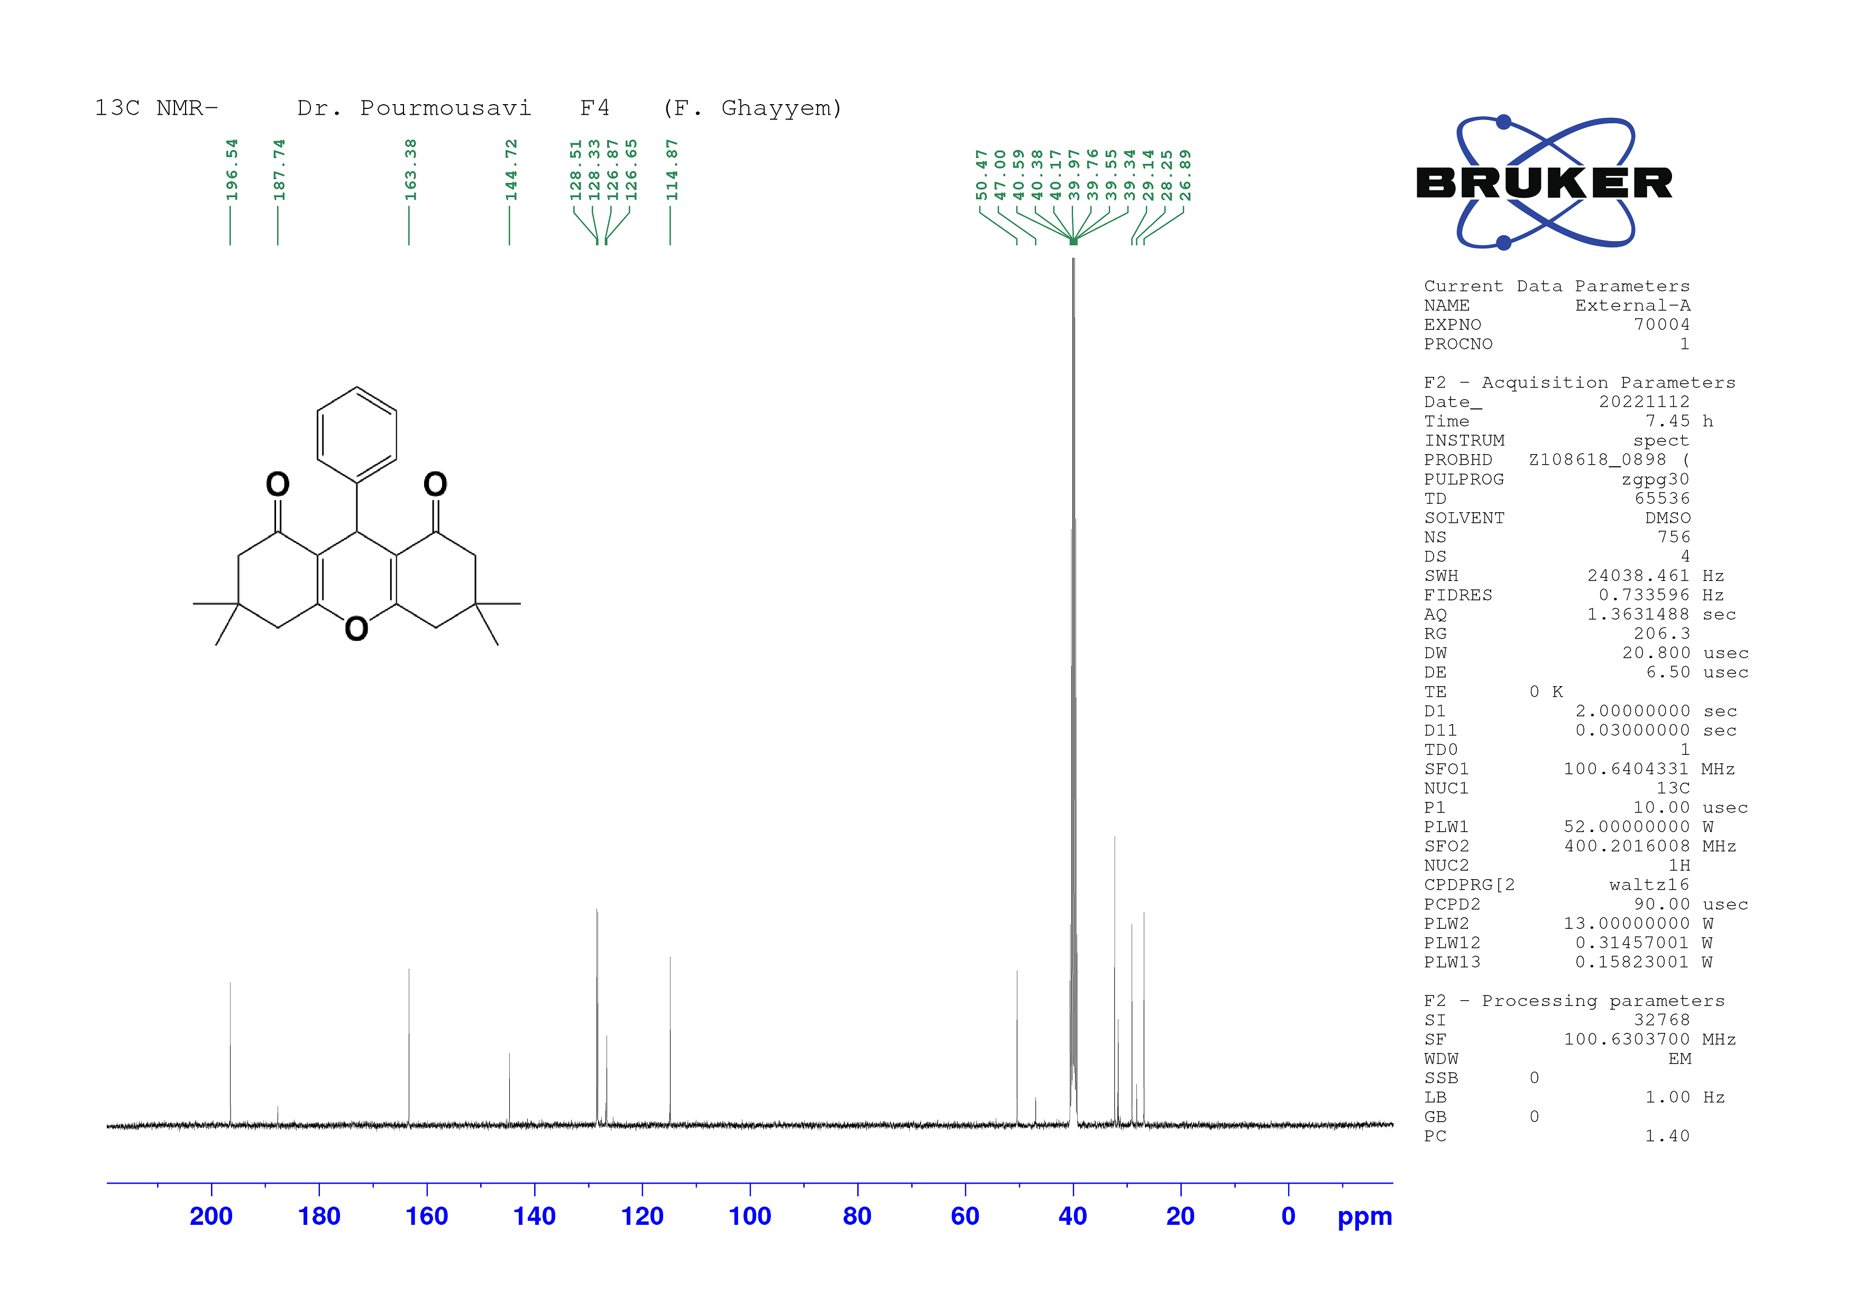
Figure S2: ¹³C-NMR spectrum of 3,3,6,6-tetramethyl-9-phenyl-3,4,5,6,7,9-hexahydro-1H-xanthene-1,8(2H)-dione
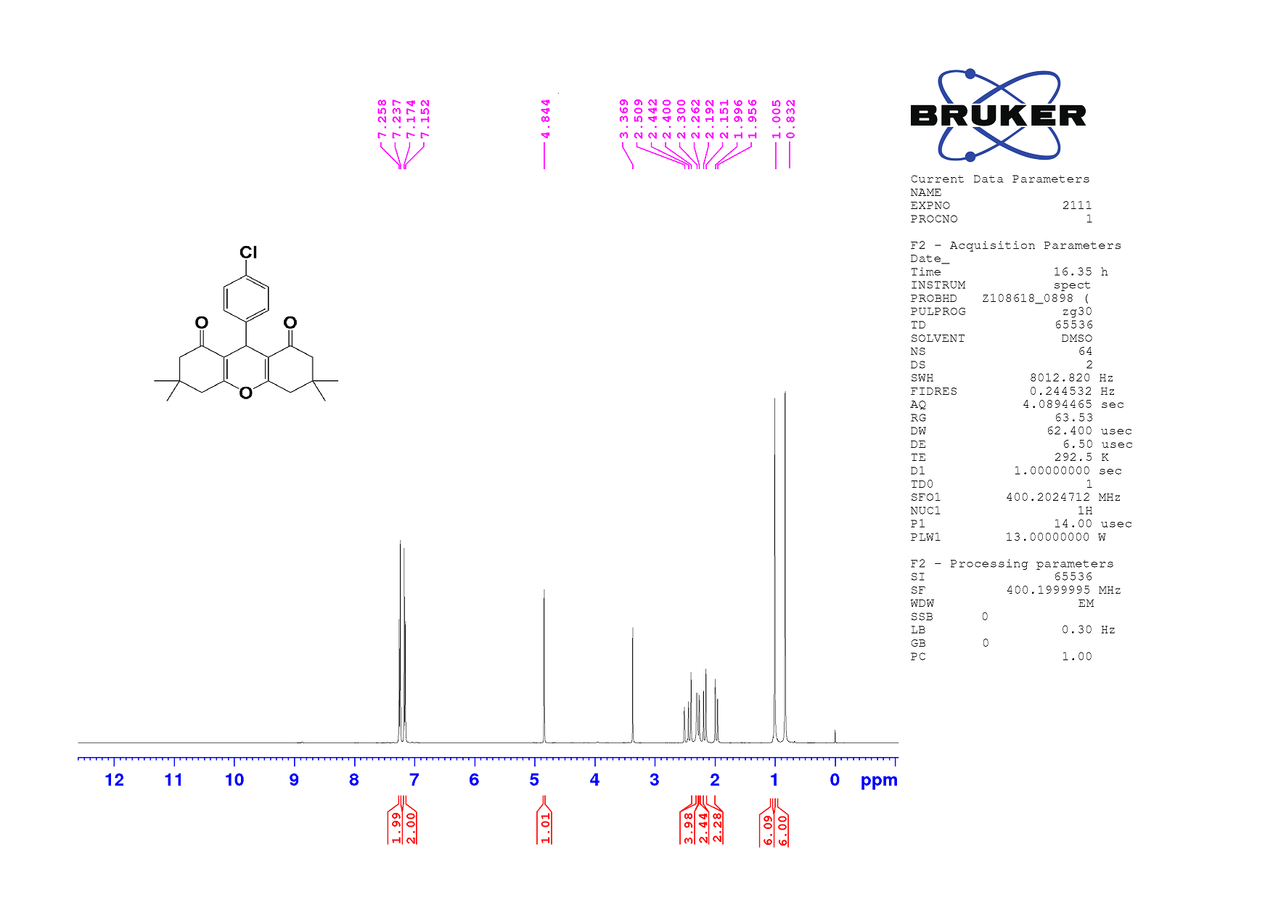
Figure S3: ¹H-NMR spectrum of9-(4-chlorophenyl)-3,3,6,6-tetramethyl-3,4,5,6,7,9-hexahydro-1H-xanthene-1,8(2H)-dione

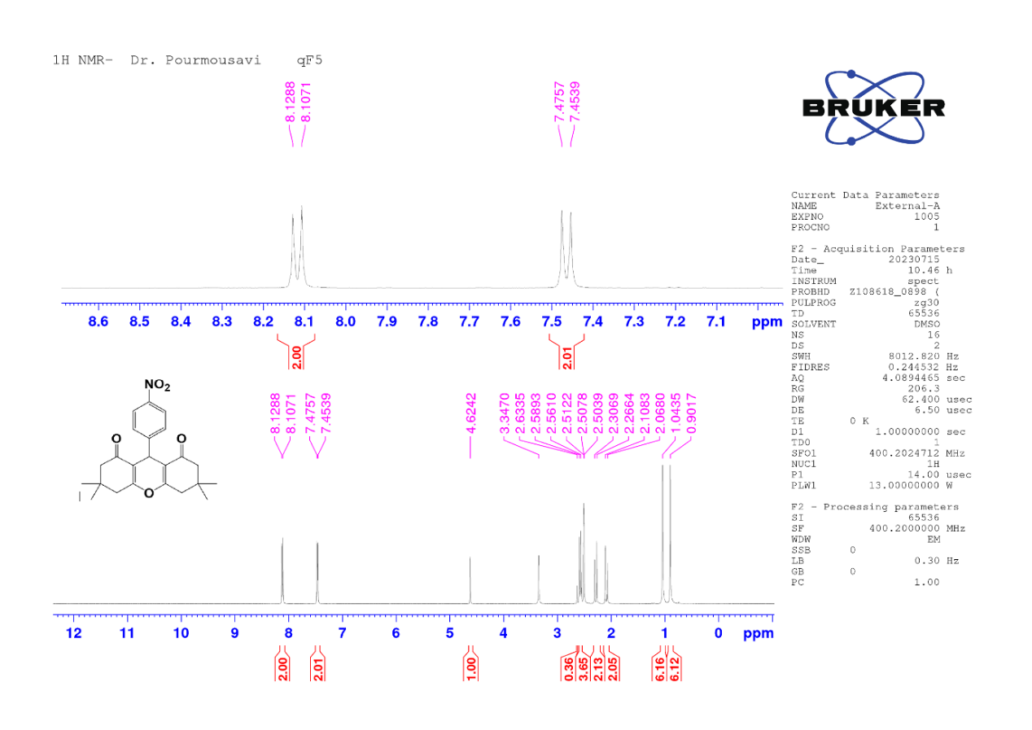
Figure S4: ¹H-NMR spectrum of 9-(4-nitrophenyl)-3,3,6,6-tetramethyl-3,4,5,6,7,9-hexahydro-1H-xanthene-1,8(2H)-dione
Figure S5: ¹³C-NMR spectrum of 9-(4-nitrophenyl)-3,3,6,6-tetramethyl-3,4,5,6,7,9-hexahydro-1H-xanthene-1,8(2H)-dione

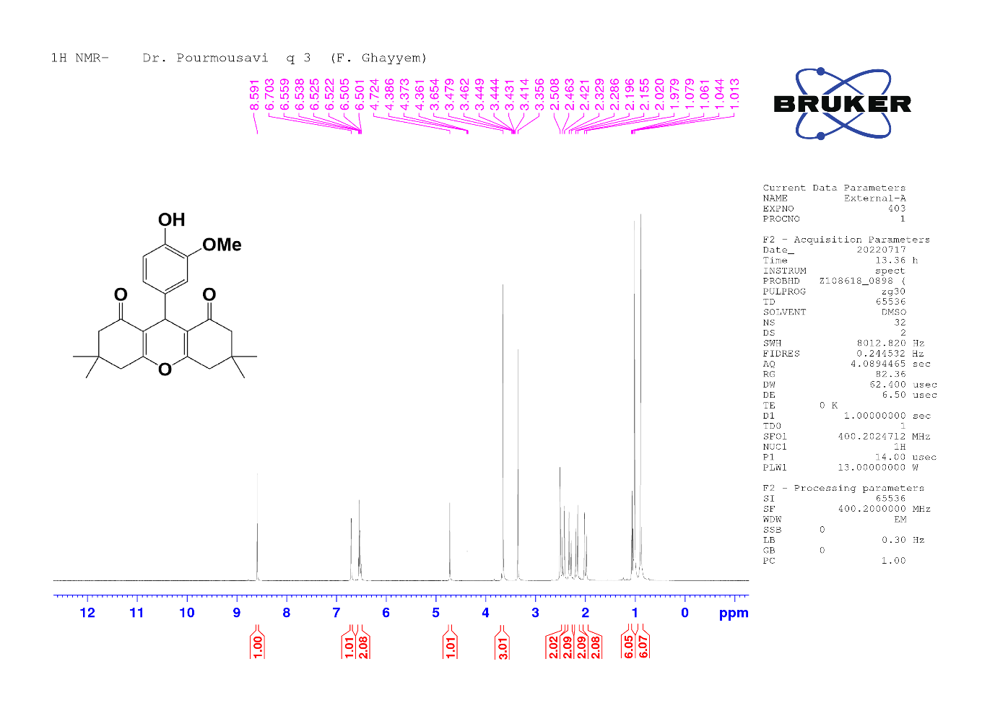
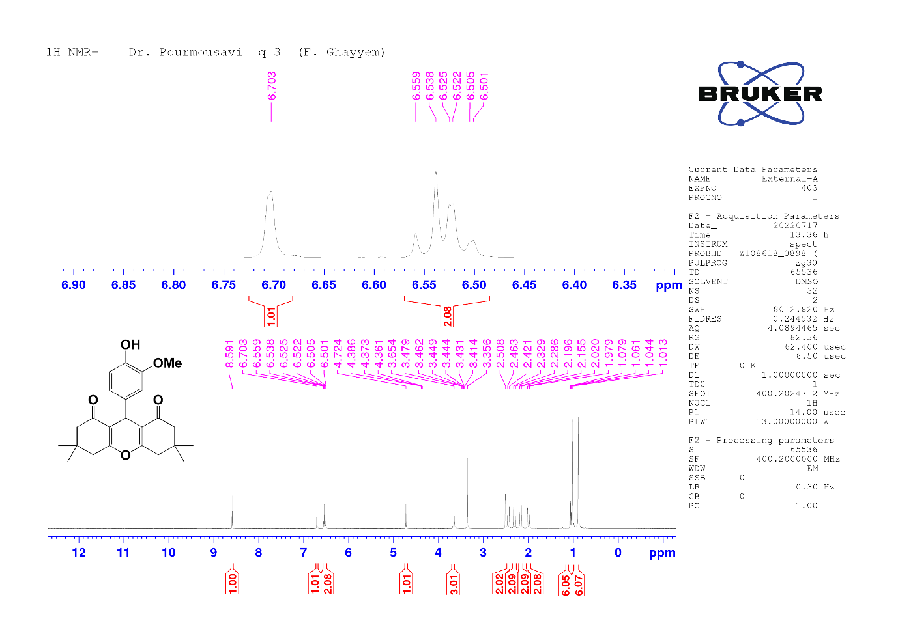
Figure S6: ¹H-NMR spectrum of 9-(4-hydroxy-3-methoxyphenyl)-3,3,6,6-tetramethyl-3,4,5,6,7,9-hexahydro-1H-xanthene-1,8(2H)-dione
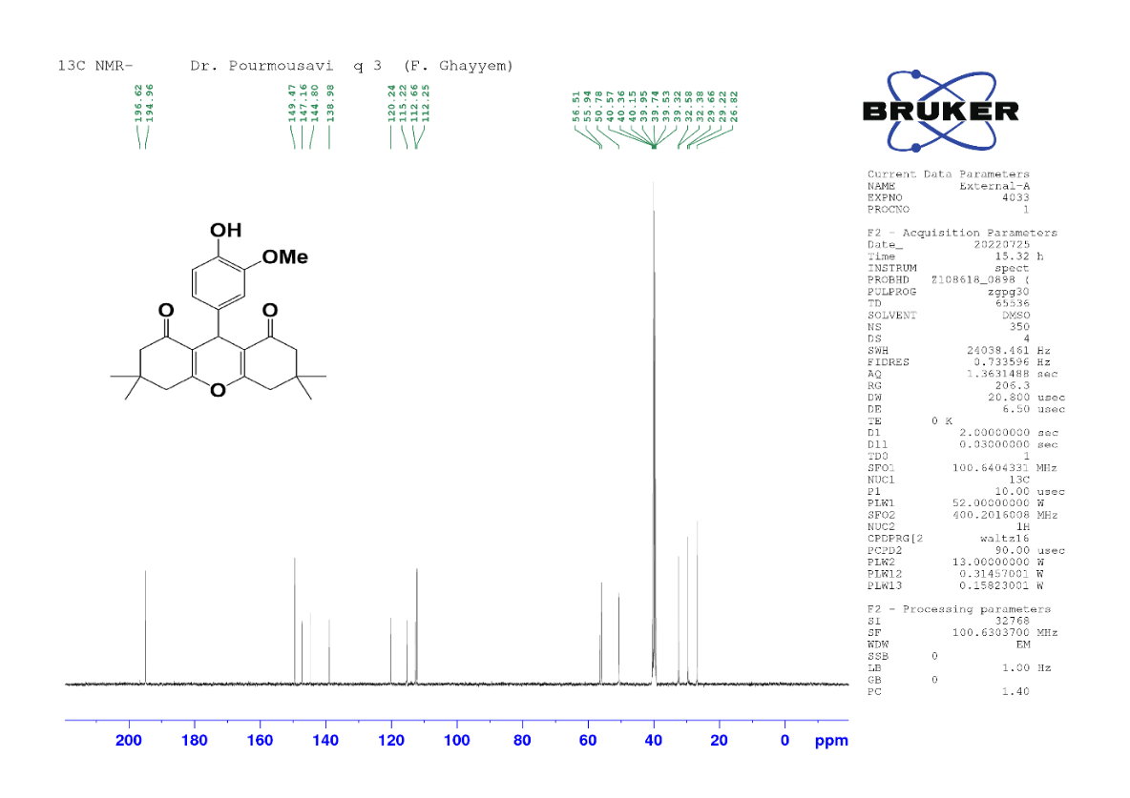
Figure S7: ¹³C-NMR spectrum of 9-(4-hydroxy-3-methoxyphenyl)-3,3,6,6-tetramethyl-3,4,5,6,7,9-hexahydro-1H-xanthene-1,8(2H)-dione

Figure S8: ¹H-NMR spectrum of 9-(naphthalen-1-yl)-3,3,6,6-tetramethyl-3,4,5,6,7,9-hexahydro-1H-xanthene-1,8(2H)-dione
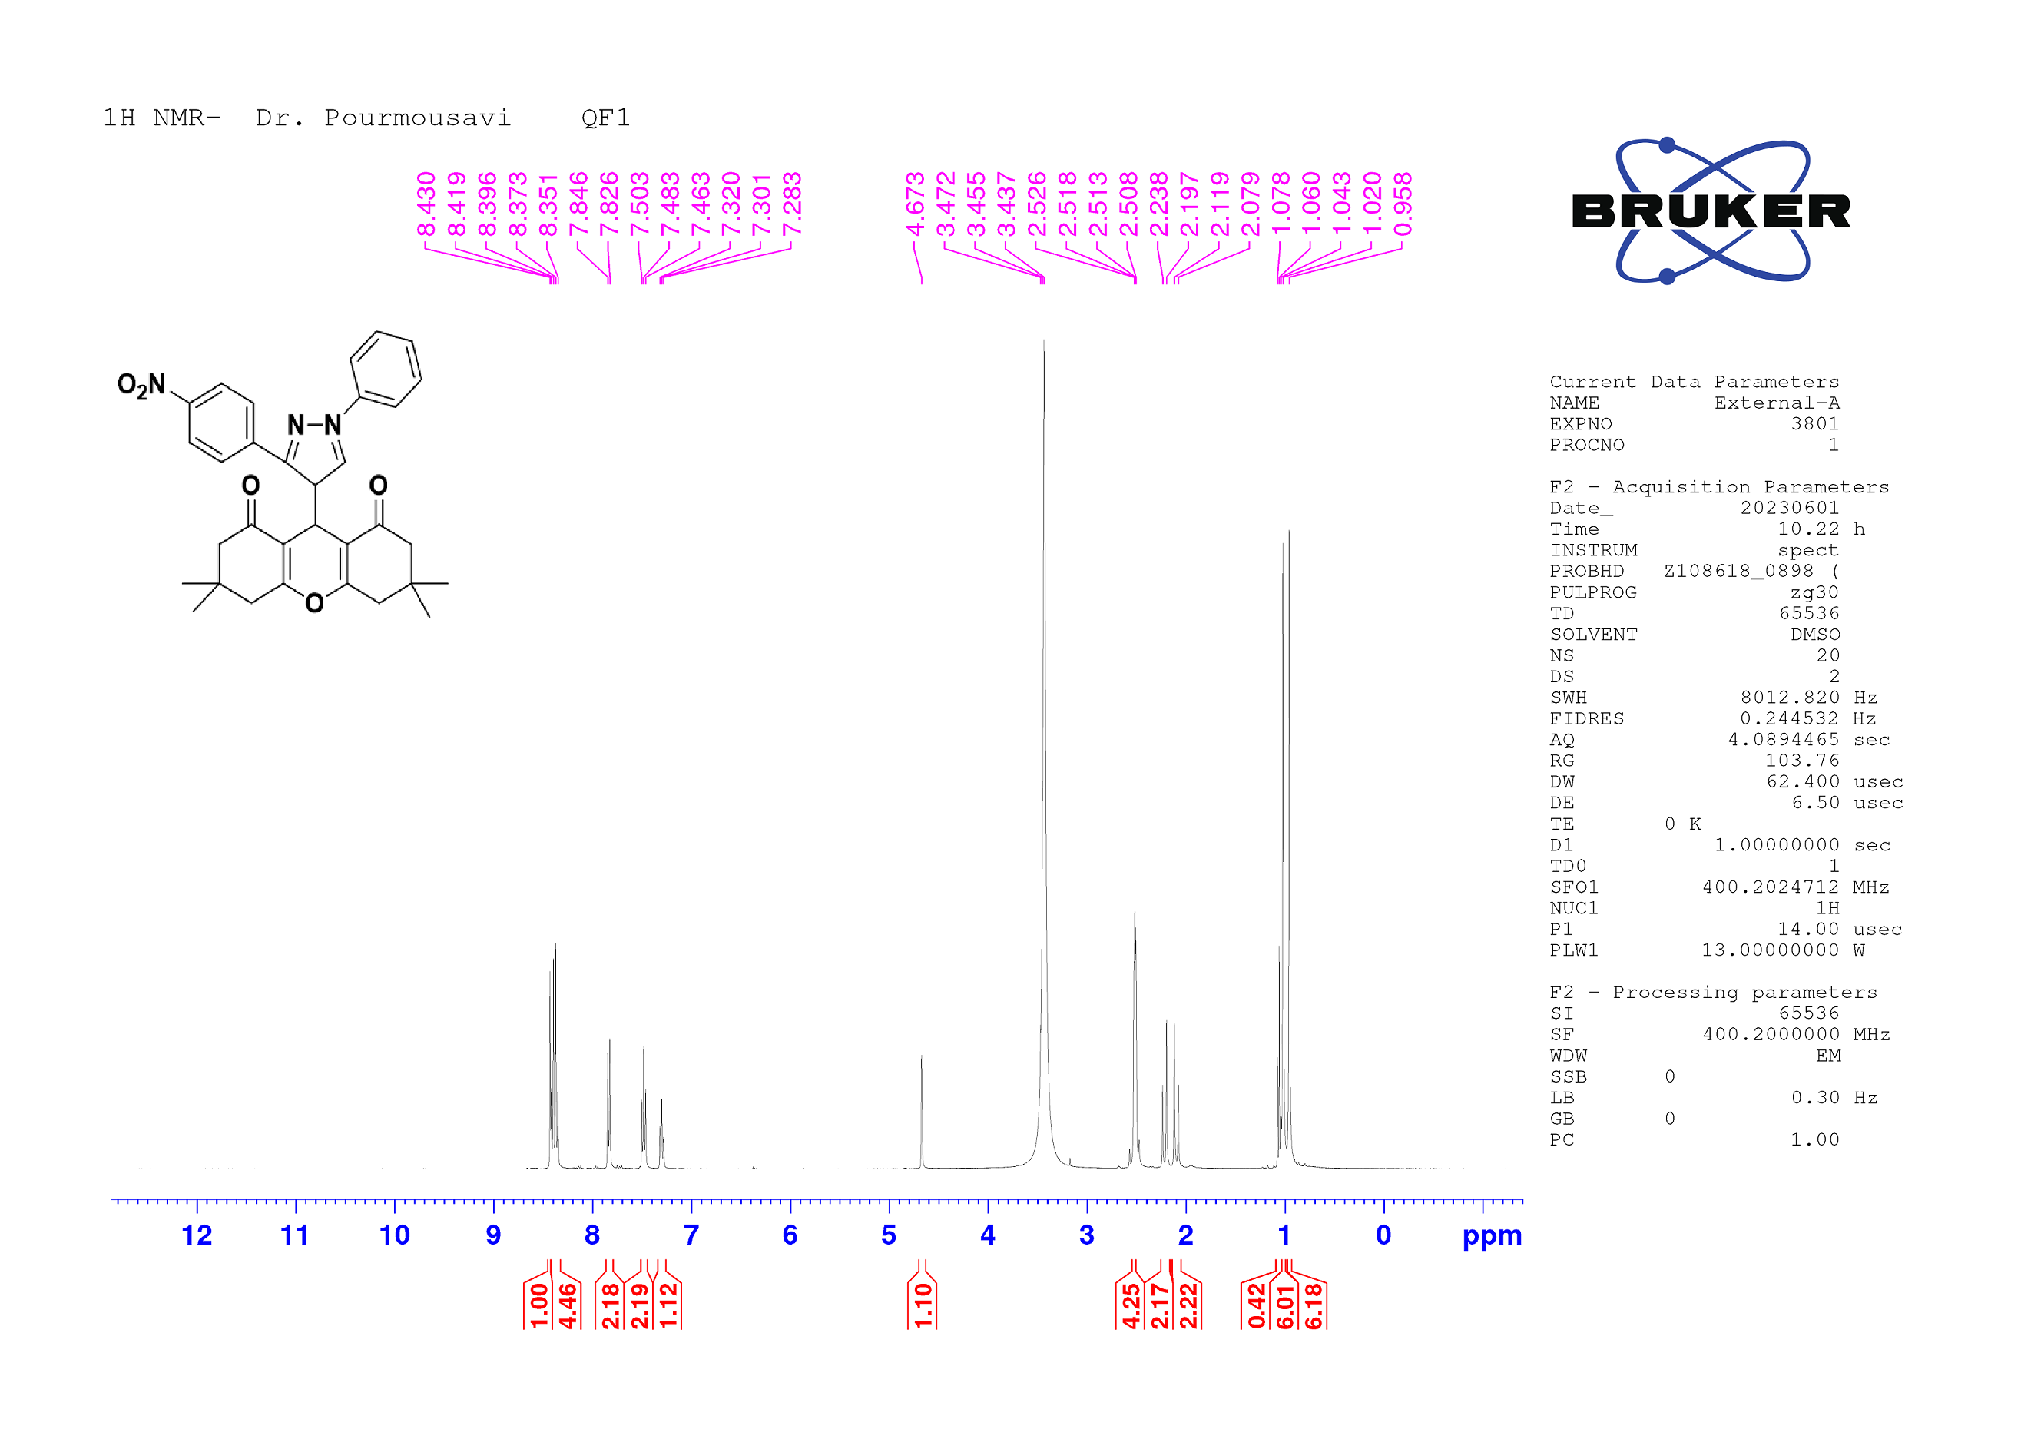
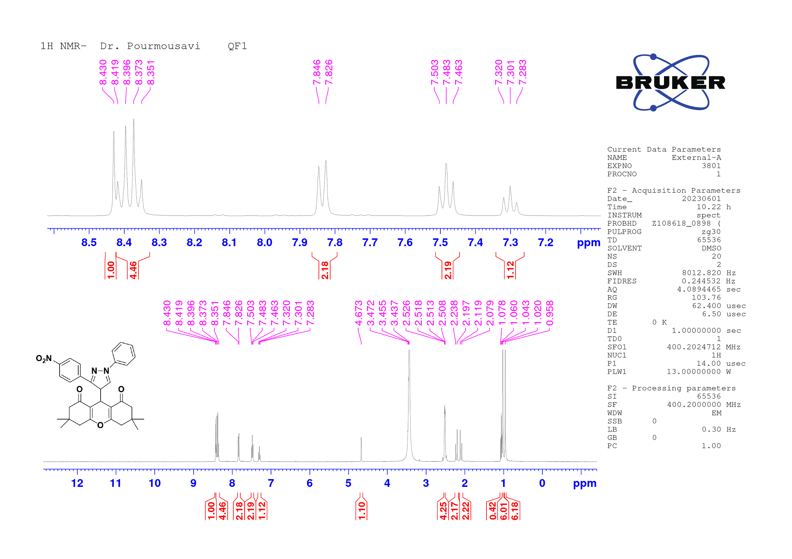
Figure S9: ¹H-NMR spectrum of 3,3,6,6-tetramethyl-9-(3-(4-nitrophenyl)-1-phenyl-4H-pyrazol-4-yl)-3,4,5,6,7,9-hexahydro-1H-xanthene-1,8(2H)-dione
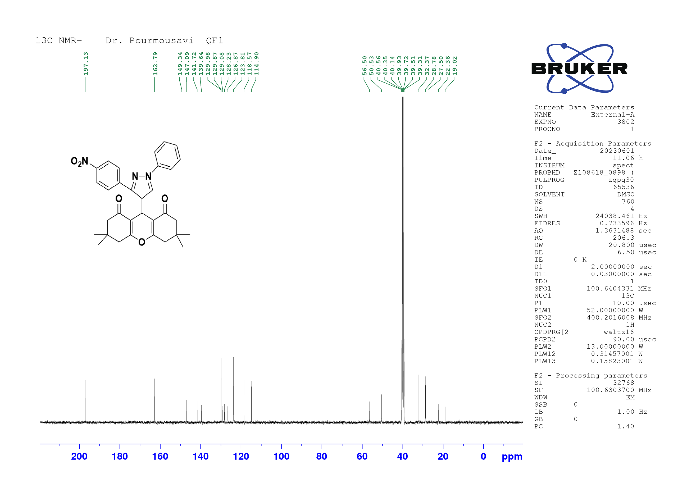
Figure S10: ¹³C-NMR spectrum of 3,3,6,6-tetramethyl-9-(3-(4-nitrophenyl)-1-phenyl-4H-pyrazol-4-yl)-3,4,5,6,7,9-hexahydro-1H-xanthene-1,8(2H)-dione

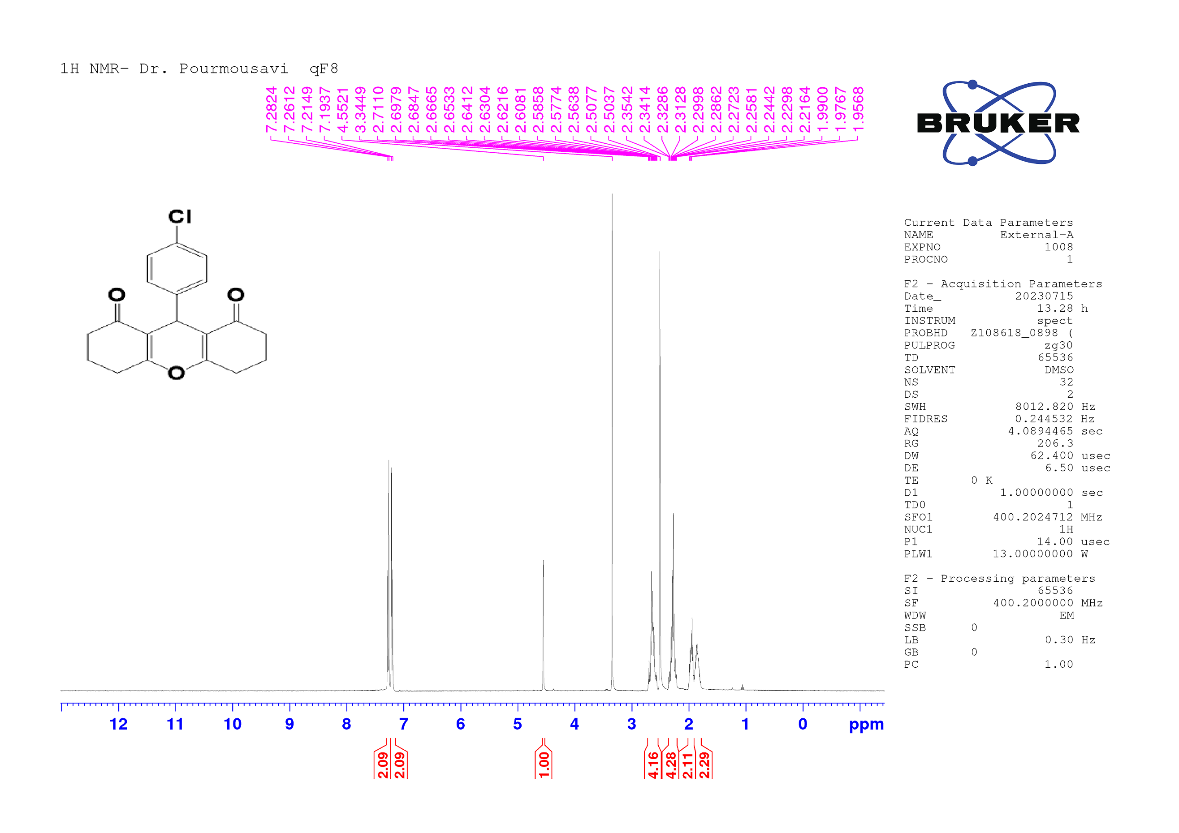
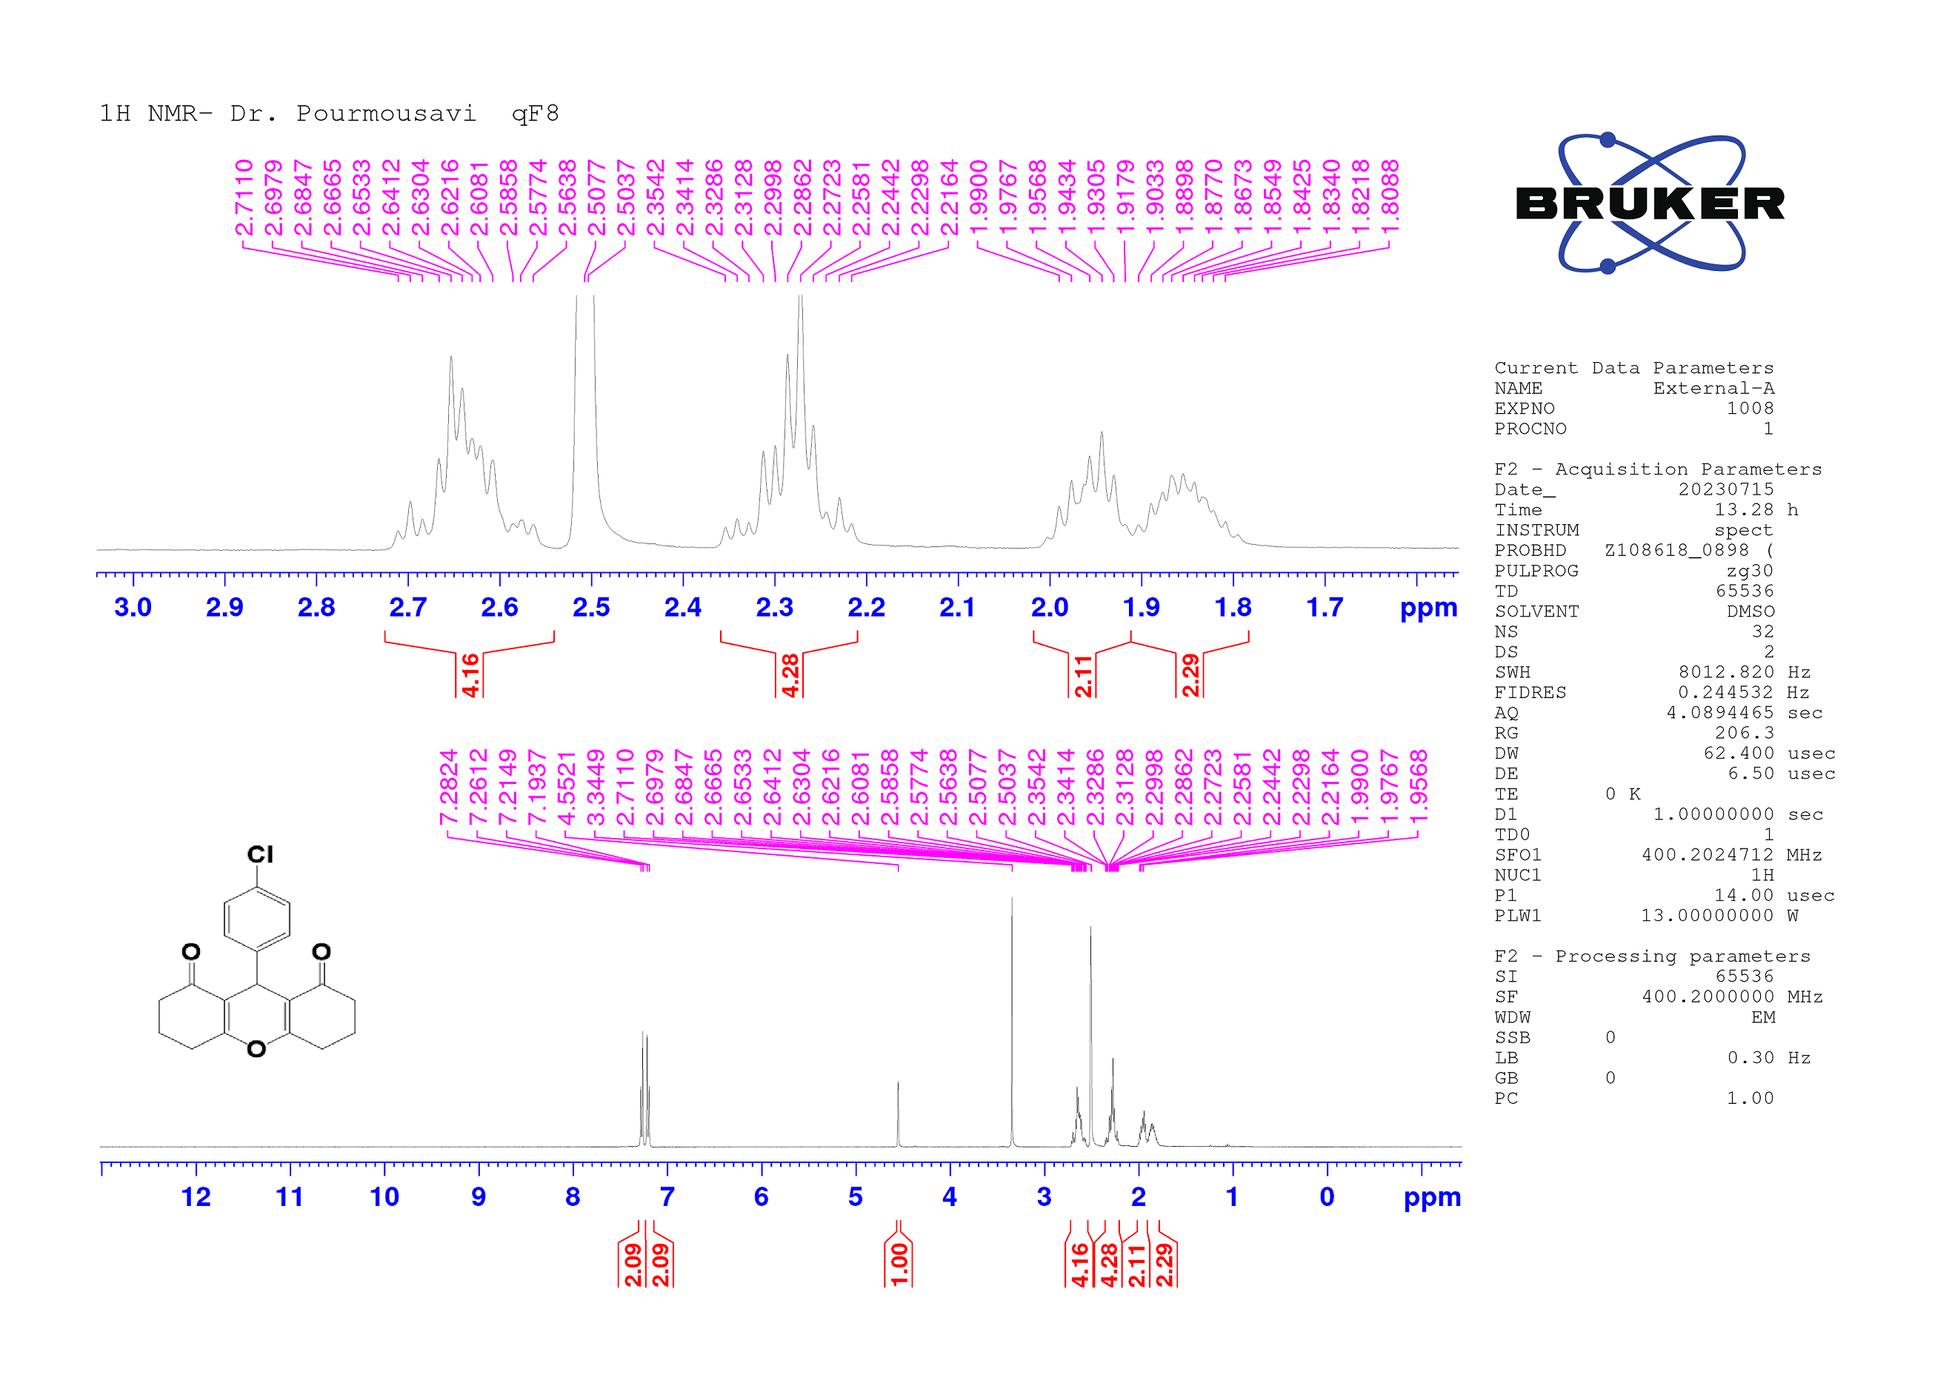
Figure S11: ¹H-NMR spectrum of 9-(4-chlorophenyl)-3,4,5,6,7,9-hexahydro-1H-xanthene-1,8(2H)-dione
Figure S12: ¹³C-NMR spectrum of 9-(4-chlorophenyl)-3,4,5,6,7,9-hexahydro-1H-xanthene-1,8(2H)-dione
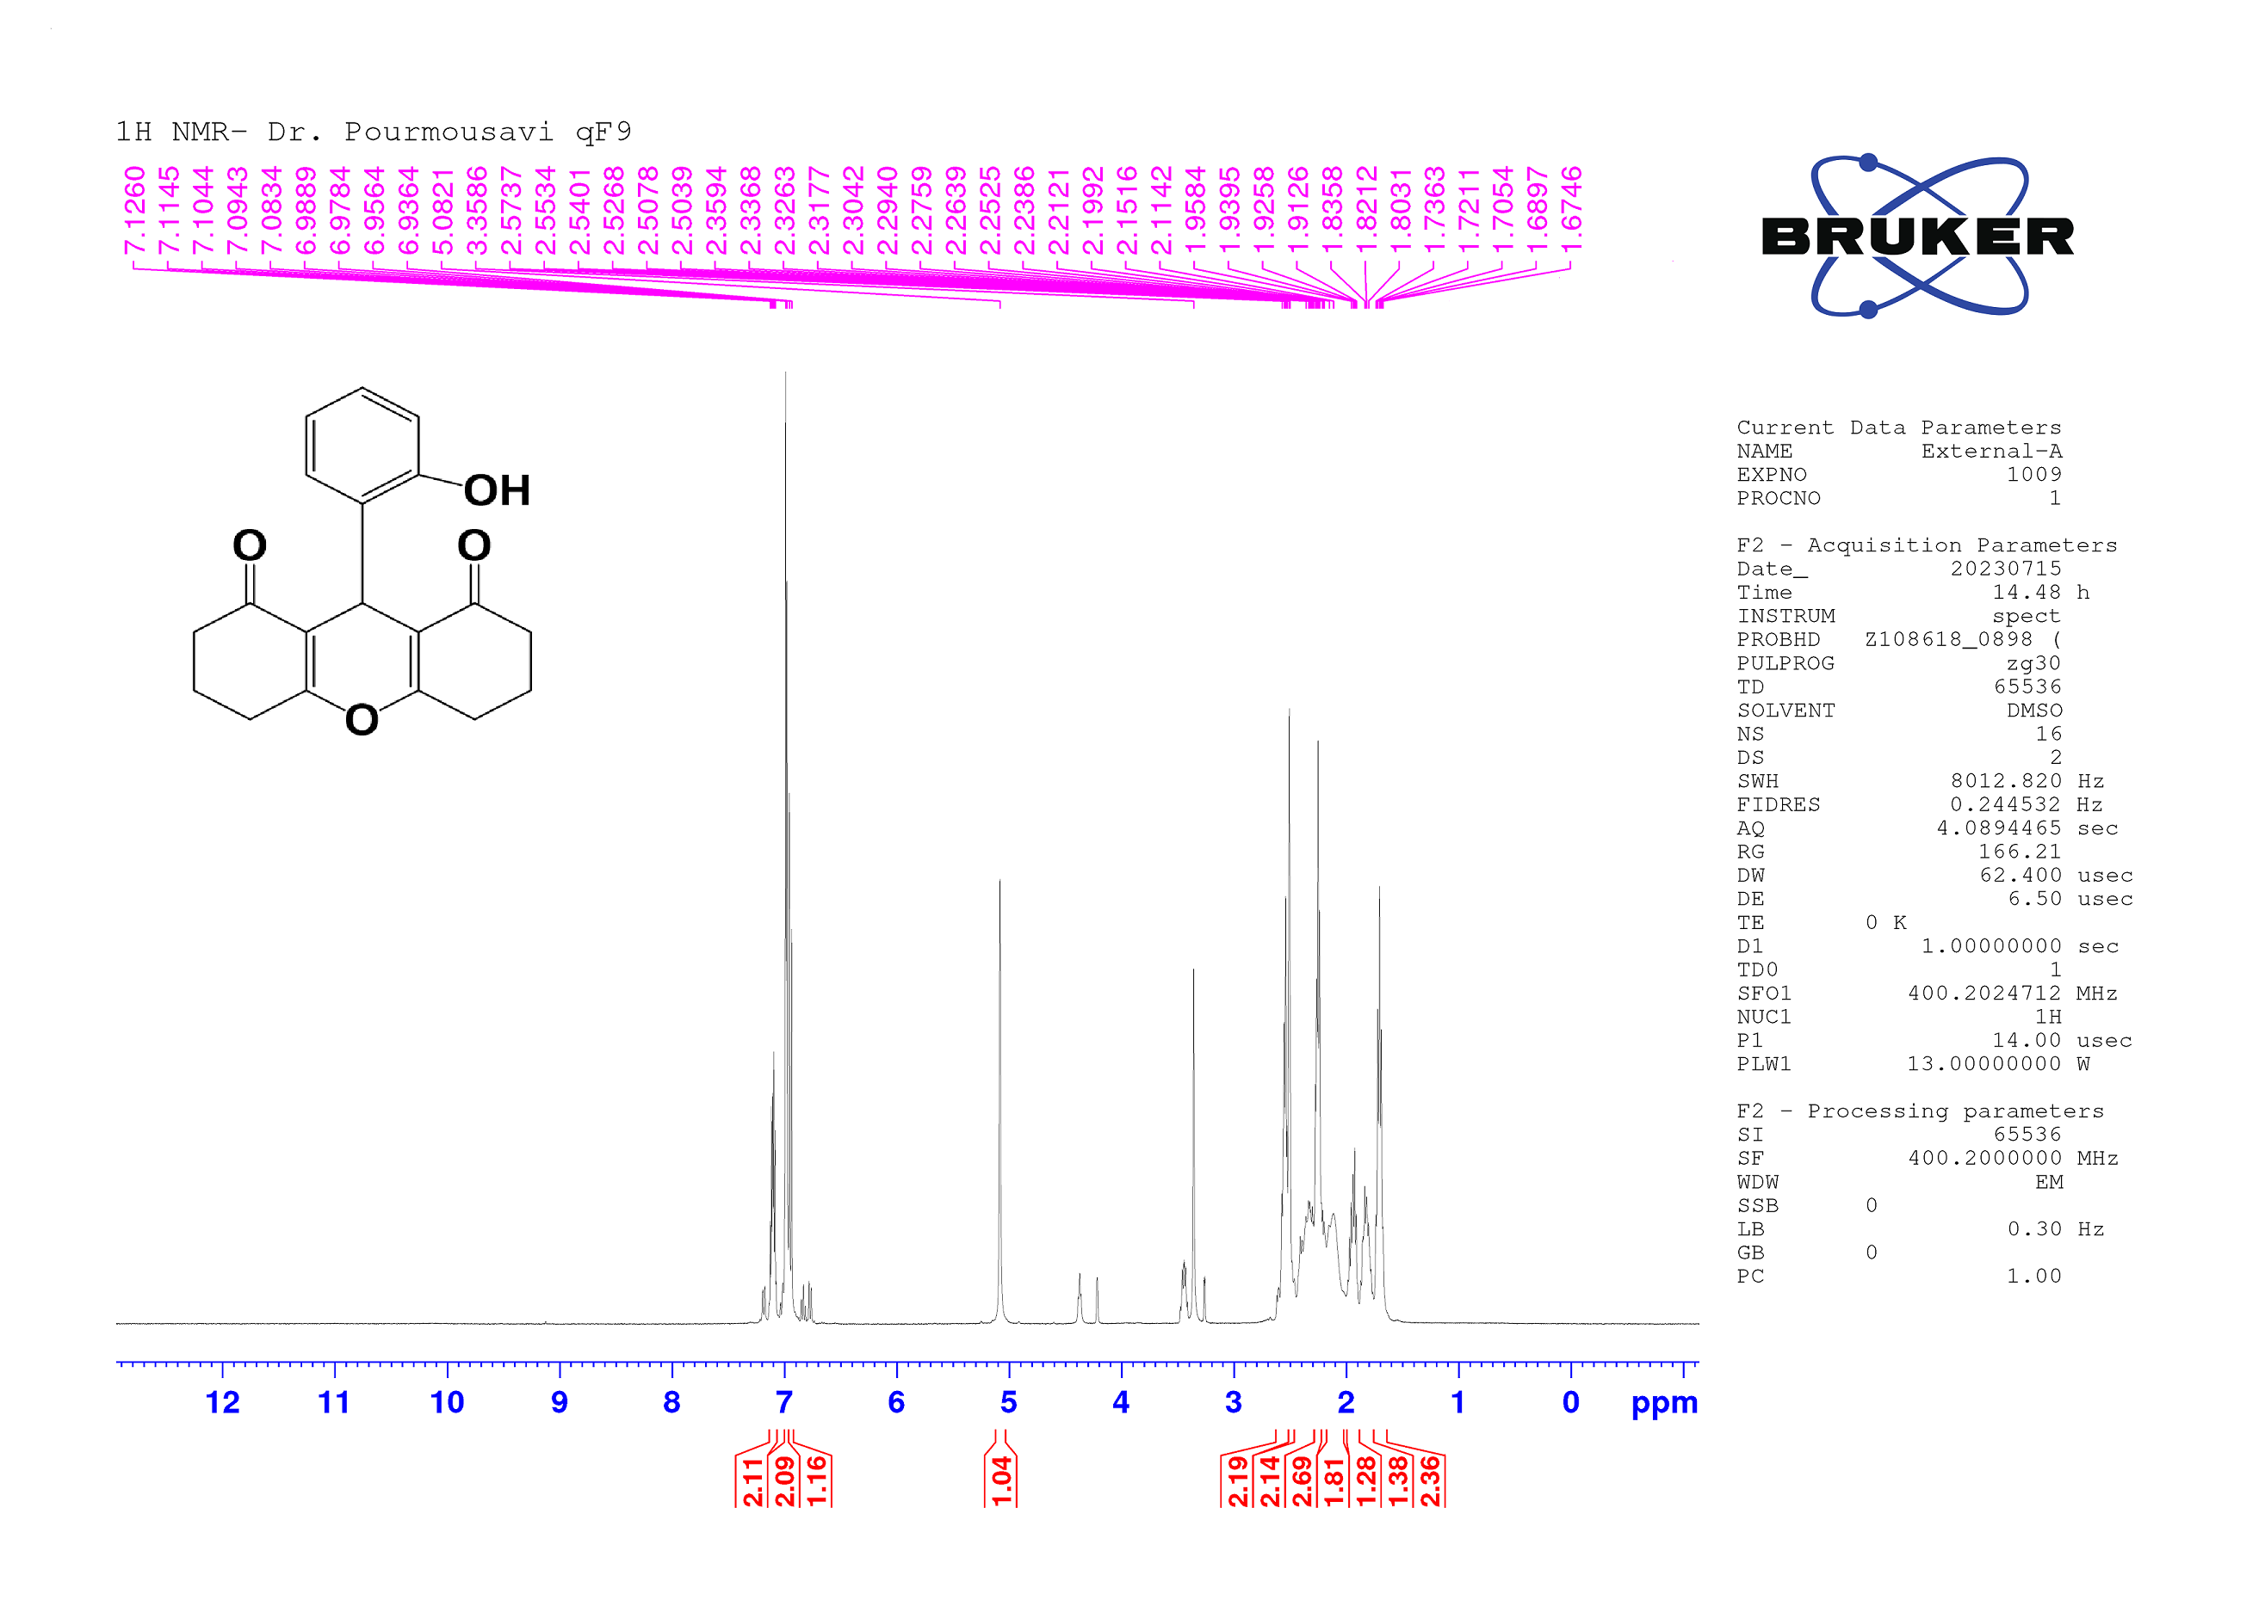

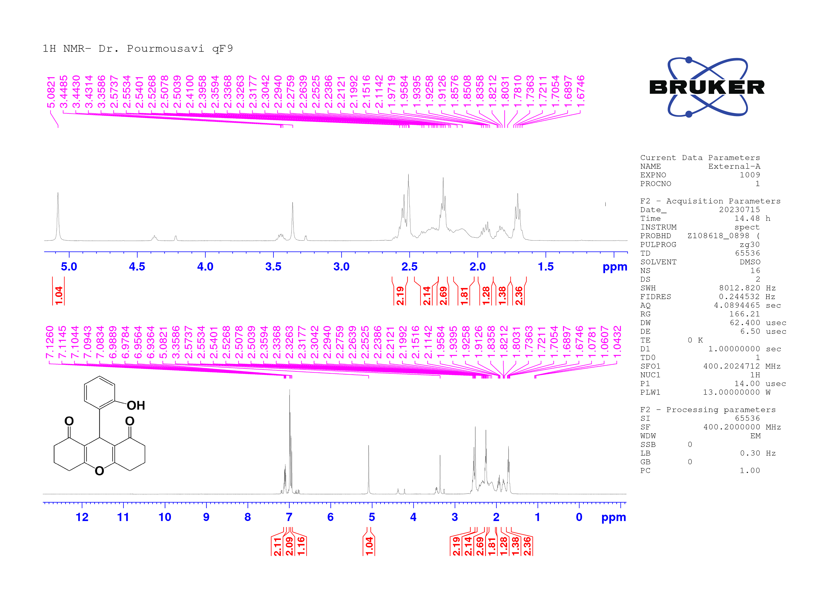
Figure S13: ¹H-NMR spectrum of 9-(2-hydroxyphenyl)-3,4,5,6,7,9-hexahydro-1H-xanthene-1,8(2H)-dione

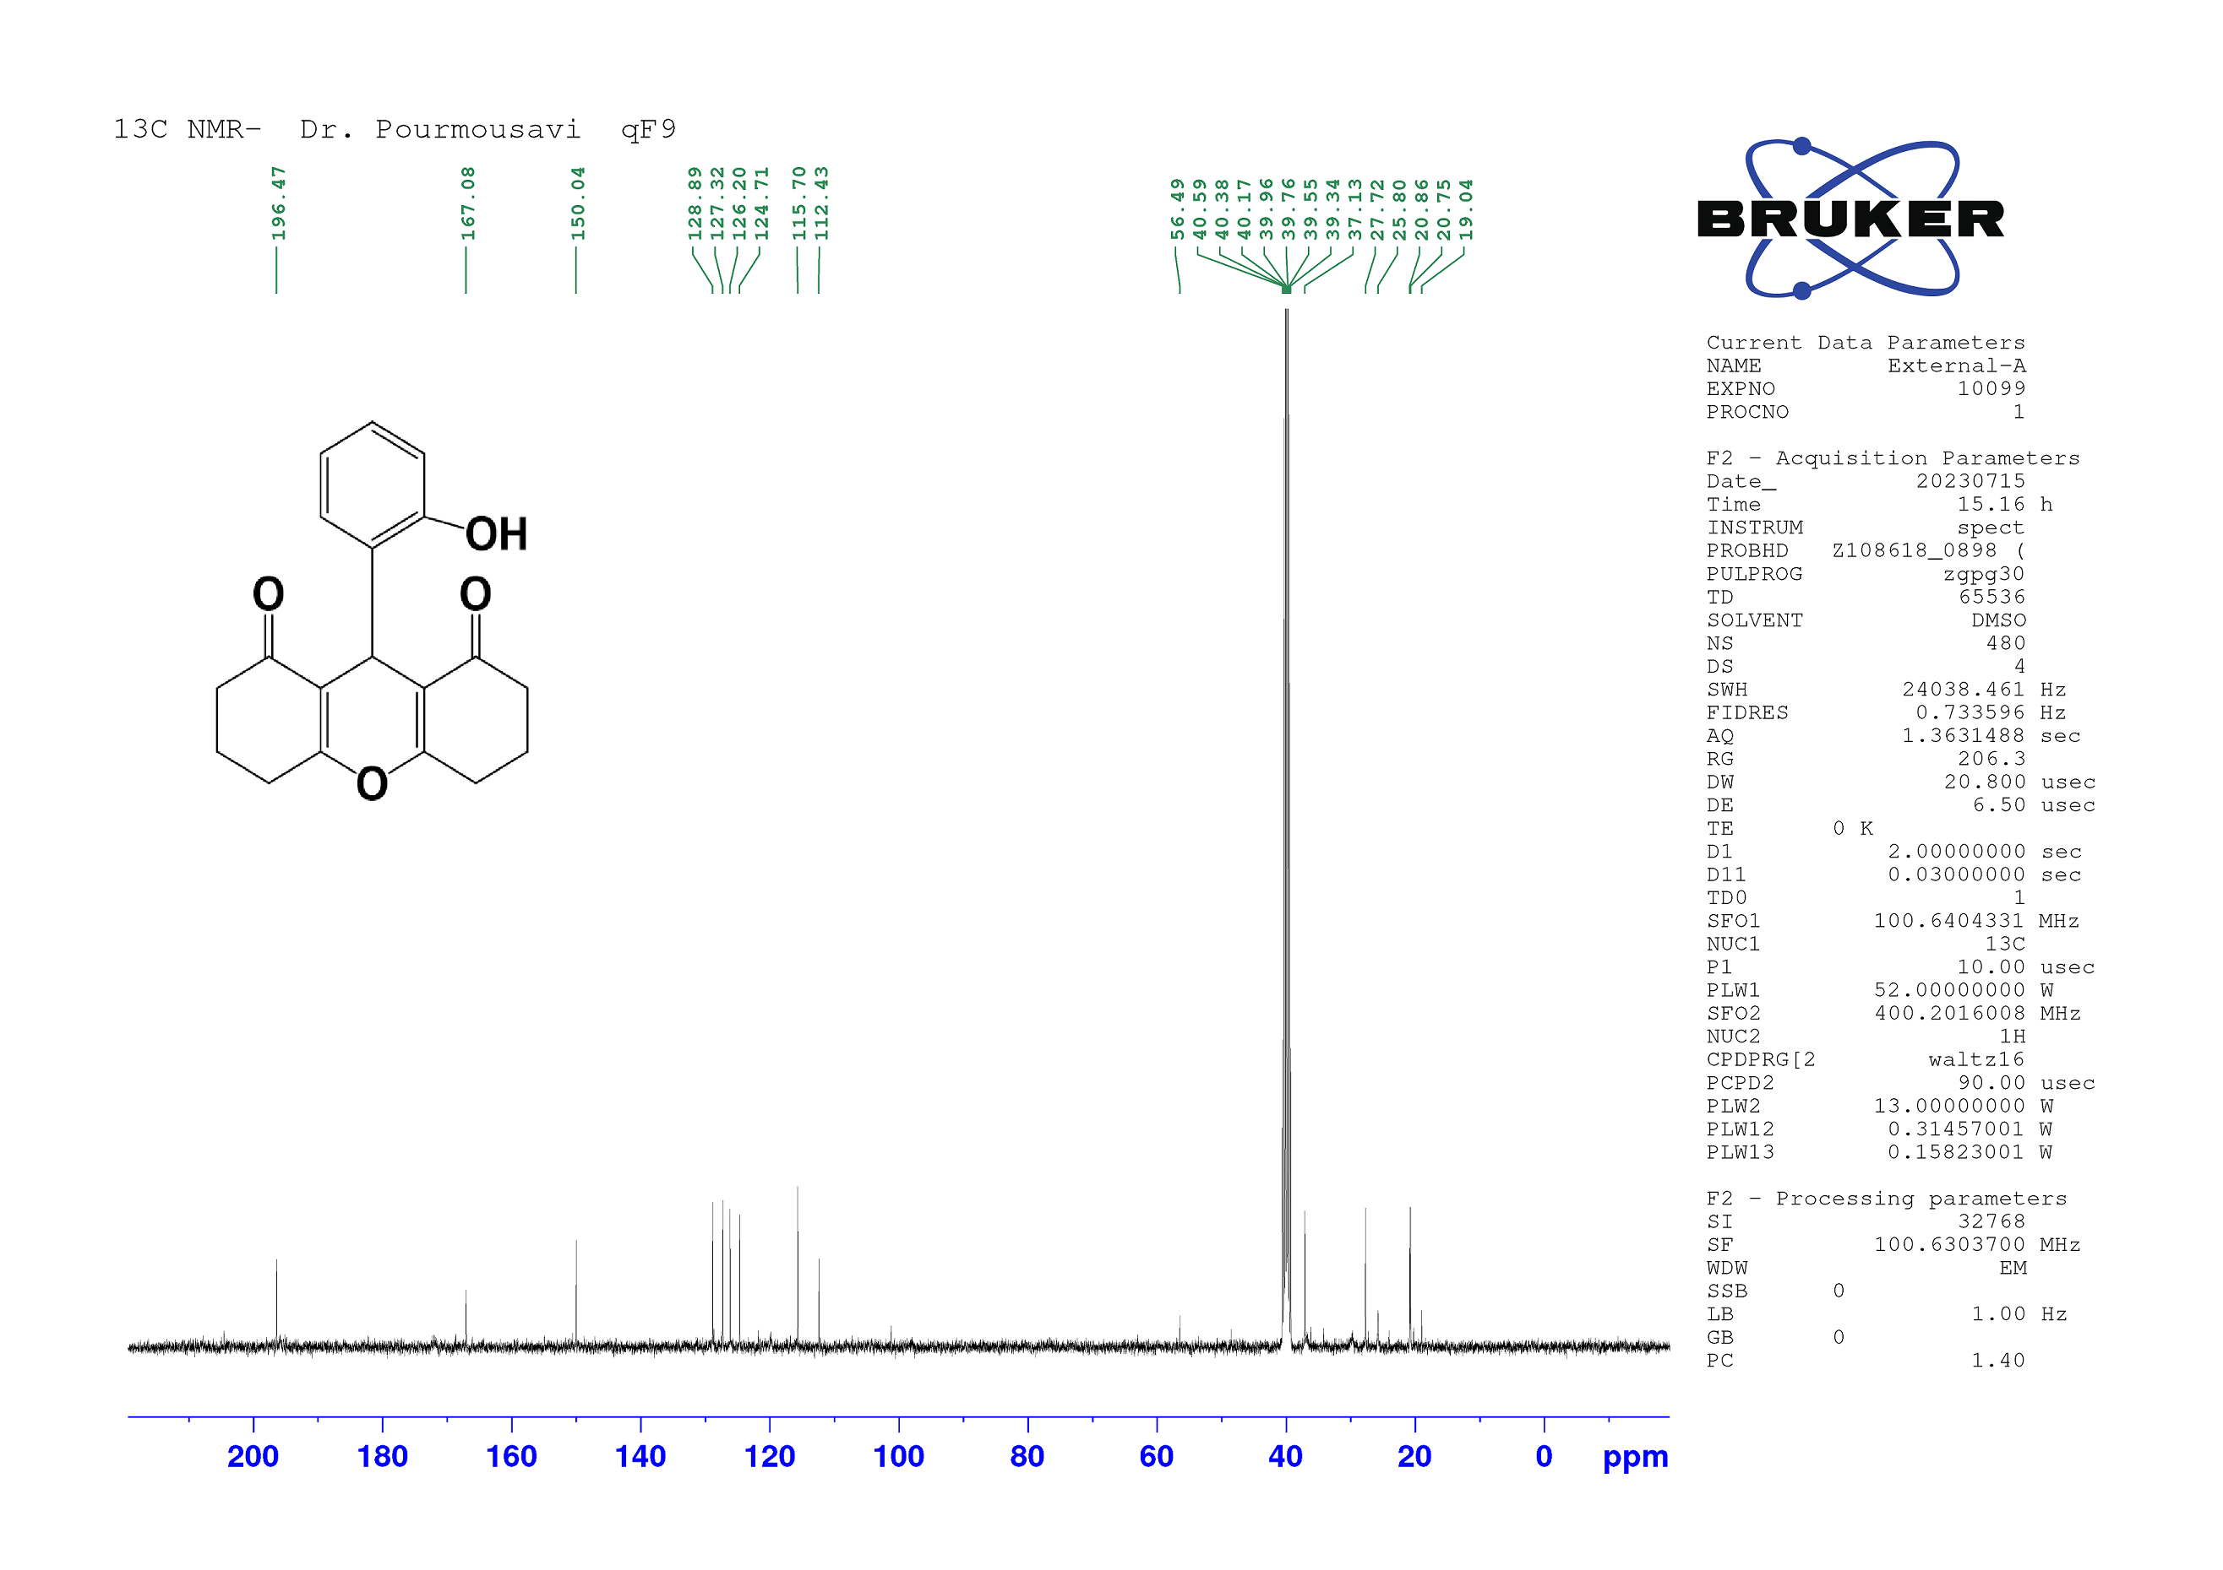
Figure S14: ¹³C-NMR spectrum of 9-(2-hydroxyphenyl)-3,4,5,6,7,9-hexahydro-1H-xanthene-1,8(2H)-dione

