Efficacious Remediation of Methylene Blue (MB) and Crystal Violet (CV) from the Aquatic Environment by Using Magnetic Hydrogel Halloysite Nanotubes
Leila Choopani¹, Mohammad Mehdi Salehi¹, Reza Eivazzadeh-Keihan*, Ali Maleki*
Catalysts and Organic Synthesis Research Laboratory, Department of Chemistry, Iran University of Science and Technology, Tehran 16846-13114, Iran.
*Corresponding authors. E-mail: reza_eivazzadeh@alumni.iust.ac.ir (Reza Eivazzadeh-Keihan), E-mail: maleki@iust.ac.ir (A. Maleki) Fax: +98-21-73021584; Tel: +98-21-7322831.
¹ These authors contributed equally.

Author’s ORCIDs:
Mohammad Mehdi Salehi: https://orcid.org/0000-0003-3648-1865
Ali Maleki: https://orcid.org/0000-0001-5490-3350
Content | Page
Table S1. All materials used in this research have been marked and are pure. | S2
Table S2. A description of the equipment used in this study. | S3
Table S3. The Surface area, Pore volume and Pore size of Ge/Pec-HNTs and Ge/Pec-HNTs@IONP magnetic hydrogel halloysite nanotubes. | S4
Table S4. Adsorption of MB and CV on the Ge/Pec-HNTs@IONP magnetic hydrogel halloysite nanotubes: isotherm, kinetic, and correlation coefficients. | S5
Figure S1. Chemical structure of )a) MB, and )b) CV. | S6
Figure S2. The standard Calibration curve for determining Methylene blue Concentration in aqueous solution. | S7
Figure S3. The standard Calibration curve for determining Crystal Violet Concentration in aqueous solution. | S8
Figure S4. Reusability of the Ge/Pec-HNTs@IONP magnetic hydrogel halloysite nanotubes (a) adsorption and (b) desorption percentages of MB and CV during two cycles. | S9
Figure S5. The suggested mechanism for adsorption of MB and CV by the Ge/Pec-HNTs@IONP magnetic hydrogel halloysite nanotubes. | S10

Table S1. All materials used in this research have been marked and are pure.
Material | Brand and Purity
Pectin (Pe) | Sigma-Aldrich, CAS Number (9000-69-5)
Gelatin (Ge) | Sigma-Aldrich, CAS Number (9000-70-8)
Halloysite nanotubes (HNTs) | Sigma-Aldrich, CAS Number (1332-58-7)
Glutaraldehyde | Sigma-Aldrich, CAS Number (111-30-8)
Sulfuric acid | ACS reagent, 95.0-98.0%, Sigma-Aldrich
Methylene Blue (MB) | Sigma-Aldrich, CAS Number (61-73-4)
Crystal Violet (CV) | Sigma-Aldrich, CAS Number (548-62-9)
Ferric chloride hexahydrate (FeCl₃·6H₂O) | ACS reagent, 97%
Ferrous chloride tetrahydrate (FeCl₂·4H₂O) | Reagent Plus®, 98%, Sigma-Aldrich
Ammonia | Puriss, anhydrous, ≥99.9%, Sigma-Aldrich
Sodium hydroxide (NaOH) | Reagent grade, ≥98%, pellets (anhydrous), Sigma-Aldrich
Hydrochloric acid (HCL) | ACS reagent, 37%
Ethanol | Sigma Aldrich (96%)

Table S2. A description of the equipment used in this study.
Equipment | Brand and model
FTIR spectroscopy | Shimadzu FT-IR-8400S
XRD | DRON-8 X-ray diffractometer
FESEM | KYKY-EM8000F
EDX spectroscopy | VEGA-TESCAN-XMU
TGA analysis | Bahr-STA 504
VSM | Kavir’s LBKFB (Kashan, Iran)
BET | Micromeritics ASAP 2010
liquid UV analysis | Shimadzu UV-2550
Thermometer | Fluke (572-2 infrared)
pH Meters | PHS-3C pH
Oven | Genlab Ltd
Filter paper | Whatman (grade 602h, Particle retention < 2µm)

Table S3. The Surface area, Pore volume and Pore size of Ge/Pec-HNTs and Ge/Pec-HNTs@IONP magnetic hydrogel halloysite nanotubes.
Sample | Surface areaª (m².g⁻¹) | Pore volume^{b} (cm³.g⁻¹) | Pore size^{b} (nm)
Ge/Pec-HNTs | 7.377 | 0.0064 | 3.514
Ge/Pec-HNTs@IONP | 35.244 | 0.0690 | 7.832
ª: By using BET analysis, the surface area parameter was obtained.
^{b}: Through BJH analysis, the pore volume and size characteristics were obtained.

Table S4. Adsorption of MB and CV on the Ge/Pec-HNTs@IONP magnetic hydrogel halloysite nanotubes: isotherm, kinetic, and correlation coefficients.
Model |  | Parameters | MB | CV
Isotherm | Freundlich | K_{F}, mg.g⁻¹ | 74.671 | 213.13
Isotherm | Freundlich | n | 2.211 | 1.764
Isotherm | Freundlich | R² | 0.9629 | 0.9950
Isotherm | Langmuir | Q_{max} (mg/g) | 434.783 | 666.667
Isotherm | Langmuir | K_{L} (L/mg) | 0.11917 | 0.55556
Isotherm | Langmuir | R² | 0.9606 | 0.9957
Kinetics | Pseudo-first-order (PFO) | K₁ (min⁻¹) | 0.0755 | 0.0124
Kinetics | Pseudo-first-order (PFO) | Q_{e, experimental} (mg/g) | 208.684 | 241.955
Kinetics | Pseudo-first-order (PFO) | Q_{e calculated} (mg/g) | 65.157 | 15.602
Kinetics | Pseudo-first-order (PFO) | R² | 0.988 | 0.9485
Kinetics | Pseudo-second-order (PSO) | k₂ (min⁻¹) | 0.00320 | 0.00569
Kinetics | Pseudo-second-order (PSO) | Q_{e, experimental} (mg/g) | 208.684 | 241.955
Kinetics | Pseudo-second-order (PSO) | Q_{e calculated} (mg/g) | 222.222 | 243.902
Kinetics | Pseudo-second-order (PSO) | R² | 0.9961 | 0.9992

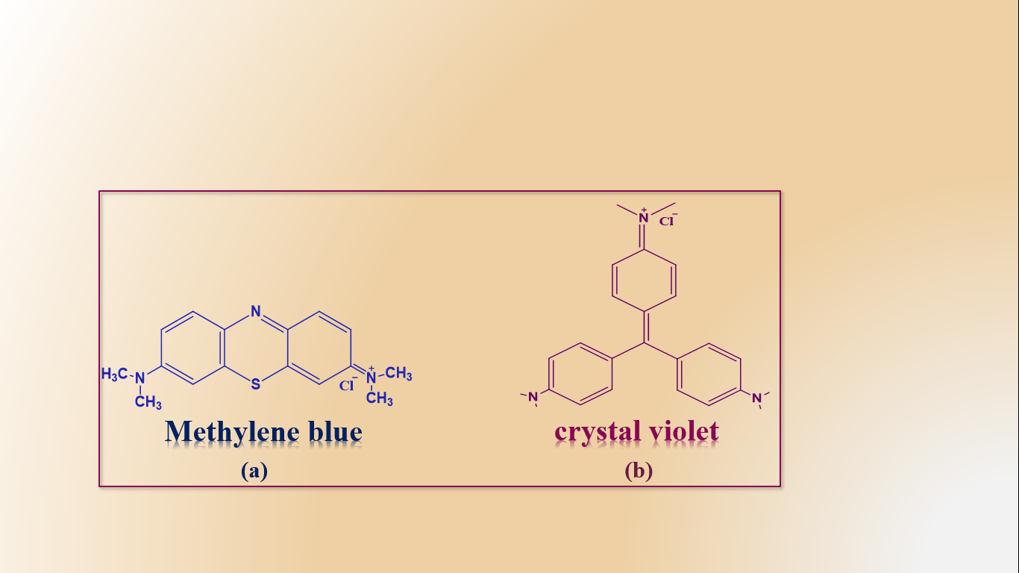
Figure S1. Chemical structure of )a) MB, and )b) CV.

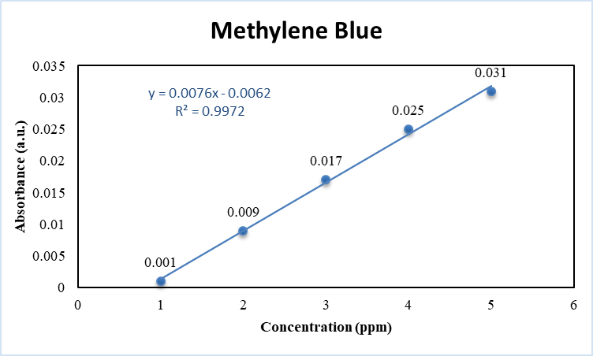
Figure S2. The standard Calibration curve for determining Methylene blue Concentration in aqueous solution.

Figure S3. The standard Calibration curve for determining Crystal Violet Concentration in aqueous solution.

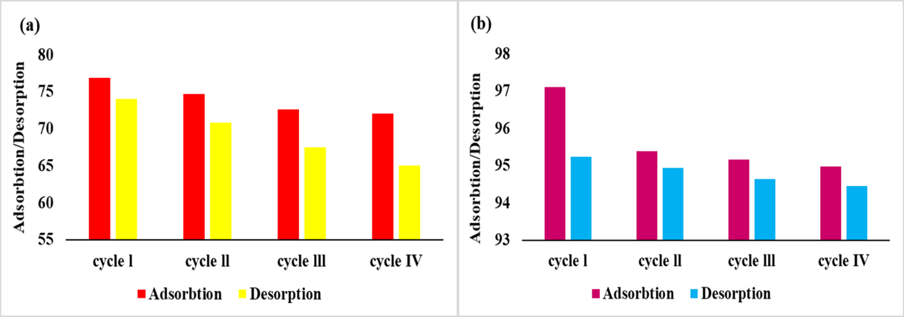
Figure S4. Reusability of the Ge/Pec-HNTs@IONP magnetic hydrogel halloysite nanotubes (a) adsorption and (b) desorption percentages of MB and CV during two cycles.

