**Supporting Information**

**Rapid Adsorption Mechanism of Methylene Blue onto a Porous Mixed Ti-Nb Oxide**

Tahmina Akter1*, Jose L. Bañuelos2, Daniel Andrade1, Dante I. Bañuelos1, Geoffrey B. Saupe1*

1 Department of Chemistry and Biochemistry, the University of Texas at El Paso, El Paso, TX 79968-0513, USA

2 Department of Physics, University of Texas at El Paso, El Paso, TX 79968-0513, USA

**Corresponding authors:** takter@miners.utep.edu (T. Akter); gsaupe@utep.edu (G. B. Saupe)

**S1. term, calculation of HPOX and MB-POX scattering length density, and MB+ outside the interlayers**

Analysis of the term in the UEP model may be used to determine the likelihood that some MB+ maybe located outside the interlayers. As discussed previously, the n=2 terms in the UEP model describe the pore spaces developed due to corrugation of the nanosheets. is related to physical parameters as follows:

Here and are related to the local pore/corrugation density and the volume, and is the x-ray scattering length density (SLD) difference between the walls of the porous oxide and the solvent in the pore space. In our case we use the SLD of water for the solvent SLD, because the samples were rinsed several times, and if present, any excess MB+, which is not in the interlayers, would be adsorbed on the pore walls. Because and are approximately the same value for both HPOX and MB-POX samples, the ratio of for each sample may be written in terms of the ratio for each sample:

The value obtained from the UEP fit parameter is 1.57. Next, the value was calculated from analysis of the d-spacing and volume fractions obtained from the WAXS analysis to determine how similar the square of the ratio is to 1.57.

The average SLD ( of the nanosheets is given by the volume-weighed fractions of each component in the system. Within the MB+ containing interlayers, the volume-weighed SLD of MB+ and the (TiNbO5ˉ )n sheet is given by

Here and are the thickness of the MB+ and (TiNbO5ˉ )n layers respectively, are the x-ray scattering length density of each phase, and the thickness ratio is equivalent to the volume ratio due the lamellar symmetry of the system. A similar expression may be written for the volume-weighed SLD of the interlayers with no MB+, which are presumed to be filled primarily with water so that is replaced by , the thickness of the water layer.

The full expression of the average SLD of the MB-POX system, then is given by:

Here, is the fraction filled with MB+, and is the fraction with no MB+. The (TiNbO5ˉ )n layer thickness is taken as , and and are calculated from the d-spacing as , and . The expression for is obtained by setting and .

The result of this calculation gives a ratio= 1.19. A ratio of 1.19 is the expected value if all MB+ is inside the interlayers. Because the G2 parameters give a value of 1.57, this indicates that additional MB+ is present near the pore walls giving an overall higher SLD contrast with the solvent. Due to some uncertainties in the precise packing fraction of each sample, as well as possible deviations from bulk density, which are likely in the aforementioned adsorbed and nano confined MB+ materials, it is difficult to provide a precise estimate of the extra amount of MB+ outside the interlayers.

**Figure S1.** X-ray diffraction (XRD) pattern of the powdered compound, KTiNbO5. This data is provided for comparison with the x-ray pattern data of the synthesized MB-POX material in the main article. To verify syntheses, XRD patterns of synthesized KTiNbO5 powders were matched with the JCPDS pattern file no: 054-1155. KTiNbO5 has an orthorhombic crystal structure.S1 For clarity, not all peaks are labeled here, but the library pattern match is conclusive.

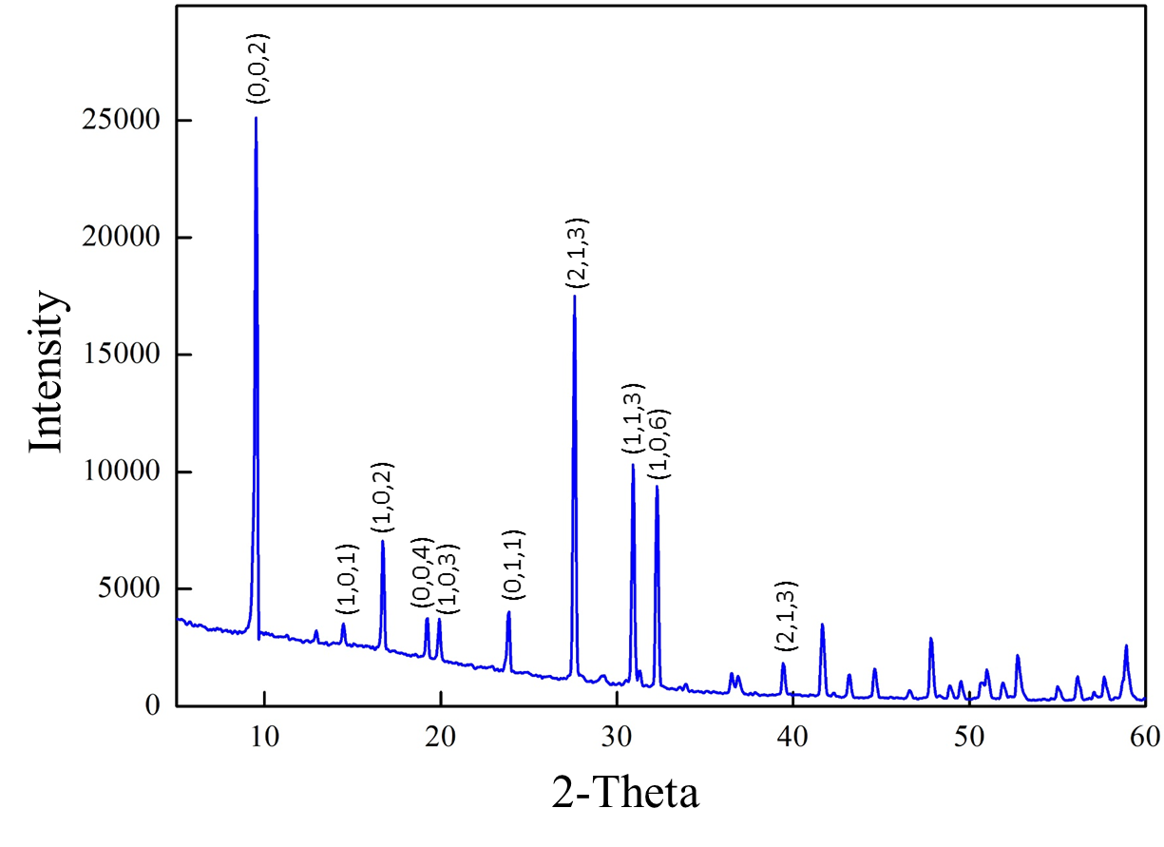

On curve (a) MB+, the peaks at 1594 and 1488 cm-1 correspond to the stretching vibrations of the aromatic rings in MB+. The band at 1396 cm-1 is due to the stretching of the C-N bond. In b) MB-POX, the C-N bond stretch peak shifted to 1389 cm-1. This redshift may be due to the interaction of the MB+ molecules with the anionic host layers. C-H stretching bands at 2870 cm-1 and 2955 cm-1 were not observed in HPOX and MB-POX, which confirms the absence of TBA+ molecules.S2 The stretching vibration region of the Nb=O bond is between 1000 and 700 cm-1. The band located at 900 cm-1 is assigned to the stretching vibration of the Nb=O terminal group.S3 In MB-POX, the Nb=O terminal group vibrations has been shifted to the wavenumber of 911 cm-1.

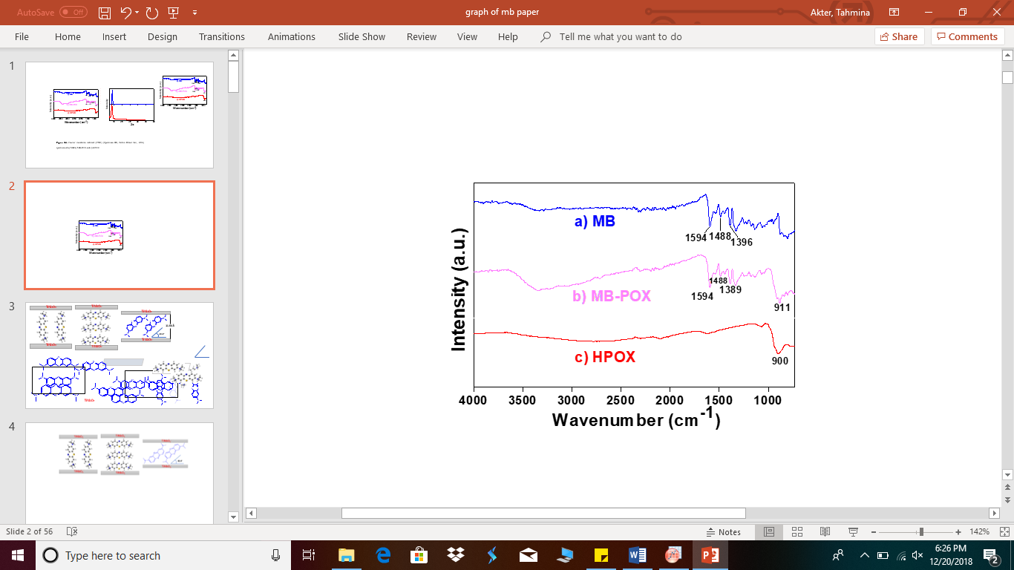

**Figure S2.**  Fourier transform infrared spectrum of (a) crystalline methylthioninium chloride (methylene blue chloride), (b) MB-POX, and (c) the HPOX host before MB+ intercalation. FTIR measurements were performed on a Spectrum-100, Perkin Elmer Inc., USA.

**Figure S3.** An example of the EDX analysis of air dried MB-POX samples. Relevant discussion and experimental details are presented in the main paper.

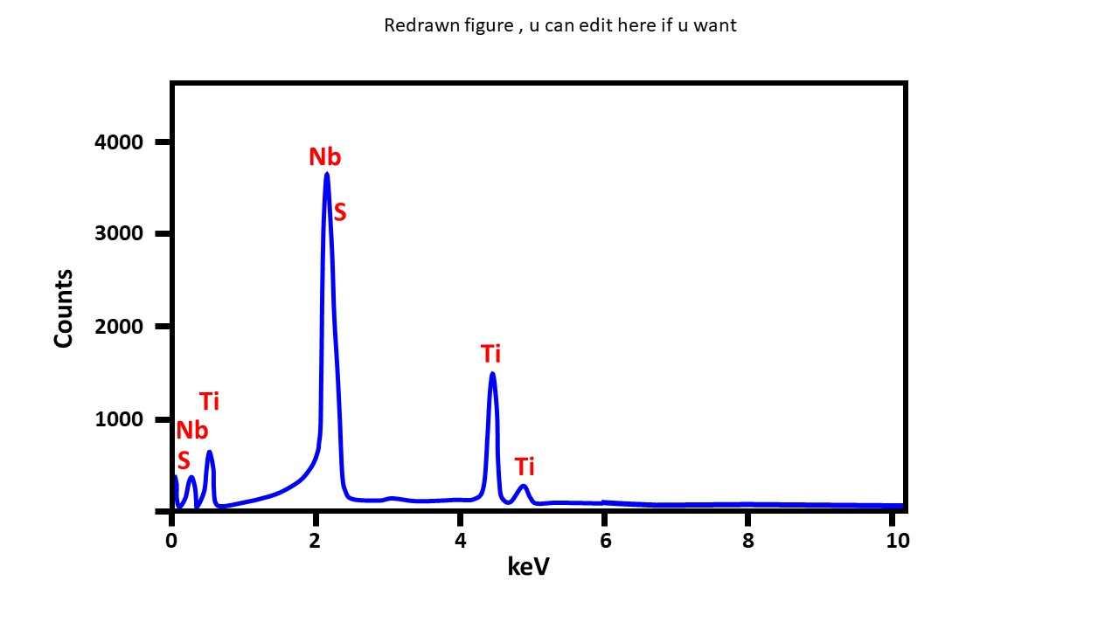

**S2. Synthesis of** **acid-restacked HexaPOX from potassium hexaniobate (****K4Nb6O17)**

K4Nb6O17 was synthesized by a conventional solid state method.S4 A mixture of finely ground potassium carbonate, K2CO3 (Fisher Chemicals, Fairlawn, New Jersey) and niobium(V) oxide (99.9%, Alfa Aesar, Ward Hill, Massachusetts) were thoroughly mixed and placed into an alumina crucible. An excess amount of K2CO3 (10 mol % of K) was also added to compensate for the loss of potassium as an oxide during the heating. The mixture was heated in a programmable furnace at 1100°C for 20 h in air (ramp rate: 10 ºC/minute). The crystalline structure of the resulting K4Nb6O17 product was verified by powder x-ray diffraction.

Acid exchange of K4Nb6O17 was carried out in 4 M aqueous hydrochloric acid solutions, stirring for 24 hours at 40 ºC. The solid was then separated from the liquid using centrifugation. The wet solid was then re-suspended and stirred again in fresh 4 M HCl for 24 hours at 40 ºC. Stirring the solid with fresh acid was done a total of five times. Finally, the solid was rinsed well with pure water and allowed to dry at room temperature. The H+ exchanged K4Nb6O17 is H4Nb6O17. An acid-base neutralization reaction occurred when tetrabutylammonium hydroxide (TBAOH, 40%, GFS Chemicals, Columbus, Ohio, USA) was added drop-wise to an aqueous suspension of H4Nb6O17 until it reached equilibrium at approximately pH 9. At this pH, the TBA+ cations are well intercalated into the interlayer spaces and the solid exfoliates into nansheets. The exfoliated sheets naturally form metal oxide nanoscrolls in the colloidal mixture.S5 The resulting colloid was stirred for one day, with TBAOH added as needed to maintain the pH. The pH was monitored using phenolphthalein as a pH indicator to ensure the state of exfoliation continued after storage. The indicator helps avoid problems with leaking potassium ions from conventional pH meter probes.

These nanosheet colloids were used to synthesize restacked nanosheet porous oxide materials, referred to here as HexaPOX. Colloids of the exfoliated H4Nb6O17, or (TBA)4Nb6O17, started at pH 9 or 10 and were precipitated by adding 3 mL of 2 M HCl dropwise into 10 mL of the colloid (15 mg/mL), while stirring. The H+ cations precipitate or restack the negatively charged colloidal sheets and nanoscrolls, agglomerating them into porous aggregated solids. The acid-restacked precipitated product HexaPOX was rinsed and washed with pure water until it reached a constant pH of 5 or 6. The HexaPOX was kept wet in ambient conditions until needed.

**References**

(S1) Rebbah, H.; Desgardin, G.; Raveau, B., Les Oxydes ATiMO5: Echangeurs Cationiques. *Mater. Res. Bull.* **1979,** *14*, 1125.

(S2) Unal, U.; Matsumoto, Y.; Tamoto, N.; Koinuma, M.; Machida, M.; Izawa, K.; Visible Light Photoelectrochemical Activity of K4Nb6O17 Intercalated with Photoactive Complexes by Electrostatic Self-Assembly Deposition. *J. Solid State Chem.* **2006,** *179*, 33.

(S3) Han, Y.-S.; Park, I.; Choy, J.-H.; Exfoliation of layered perovskite, KCa2Nb3O10, into colloidal nanosheets by a novel chemical process. *Journal of Materials Chemistry* **2001,** *11* (4), 1277-1282.

(S4) Nassau, K., Shiever, J.W. and Bernstein, J.L.; Crystal Growth and Properties of Mica‐Like Potassium Niobates; *Journal of the Electrochemical Society*, **1969,** 116 (3), 348-353.

(S5) Saupe, G.B., Waraksa, C.C., Kim, H.N., Han, Y.J., Kaschak, D.M., Skinner, D.M. and Mallouk, T.E., Nanoscale tubules formed by exfoliation of potassium hexaniobate; *Chemistry of Materials*, **2000,** 12(6), 1556-1562.